**Data Analytics Powered by Tableau**

**UNEARTHING THE ENVIRONMENTAL IMPACT OF HUMAN ACTIVITY: A GLOBAL CO2 EMISSION ANALYSIS**



Submitted by,

**Team ID: NM2023TMID04082**

**Team Leader: Christa Floral T.S.**

**Team Members: Dharfilin Risha D.R.**

**Dhirsha R.**

**Hersilin S.**

Team Size: 4

CONTENTS

1 **INTRODUCTION**

1.1 Overview

1.2 Purpose The use of this project

2 **Problem Definition & Design Thinking**

2.1 Empathy Map

2.2 Ideation & Brainstorming Map

3 **RESULT**

4 **ADVANTAGES & DISADVANTAGES**

5 **APPLICATIONS**

6 **CONCLUSION**

7 **FUTURE SCOPE**

8 **APPENDIX**

**Project Report**

Project Title: **Unearthing the Environmental Impact of Human Activity: A Global CO2 Emission Analysis**

1. INTRODUCTION
   1. Overview:

We have analysed the Global CO2 Emission from 1975 to 2020 using a dataset CO2 Emission by various country and regions of the Earth.

We have analysed the following:

1. Top World Emission

2. Top Emitting Countries

3. Co2 Emission over Time

4. Co2 Emission India vs USA

5. Total Emission by Continents

6. Co2 Emission per Capita

7. Co2 Emission by International Factors

8. Emission Rate over Years

9. Donut Charts-Coal Co2, Cement Co2, Gas Co2, Oil Co2

10. Co2 Emission over past 10 years

11. Continent Contribution in Co2 Emission

12. Cumulative Co2 and Co2 per Capita

13. Co2 Emission in 2020

14. China vs India Co2 emission due to internal factors

15. Overall Contribution by China in Co2 Emission

1.2 Purpose:

We have compared various data regarding the global CO2 Emission of various countries of the world from the year 1975 to 2020. We have come to know where India Stands among the top countries where CO2 emission is high. We were also able to find which among Coal, cement, gas , oil and other industrial elements influences the increase in the CO2 Emission in the world and also in India.

We could clearly notice the change in the CO2 Emission trends over the past years. Understanding these trends have helped us to come to a conclusion in finding a solution for reducing the Global CO2 Emission which is in turn a major cause for Global Warming.

1. Problem definition & Design thinking:
   1. Empathy Map:

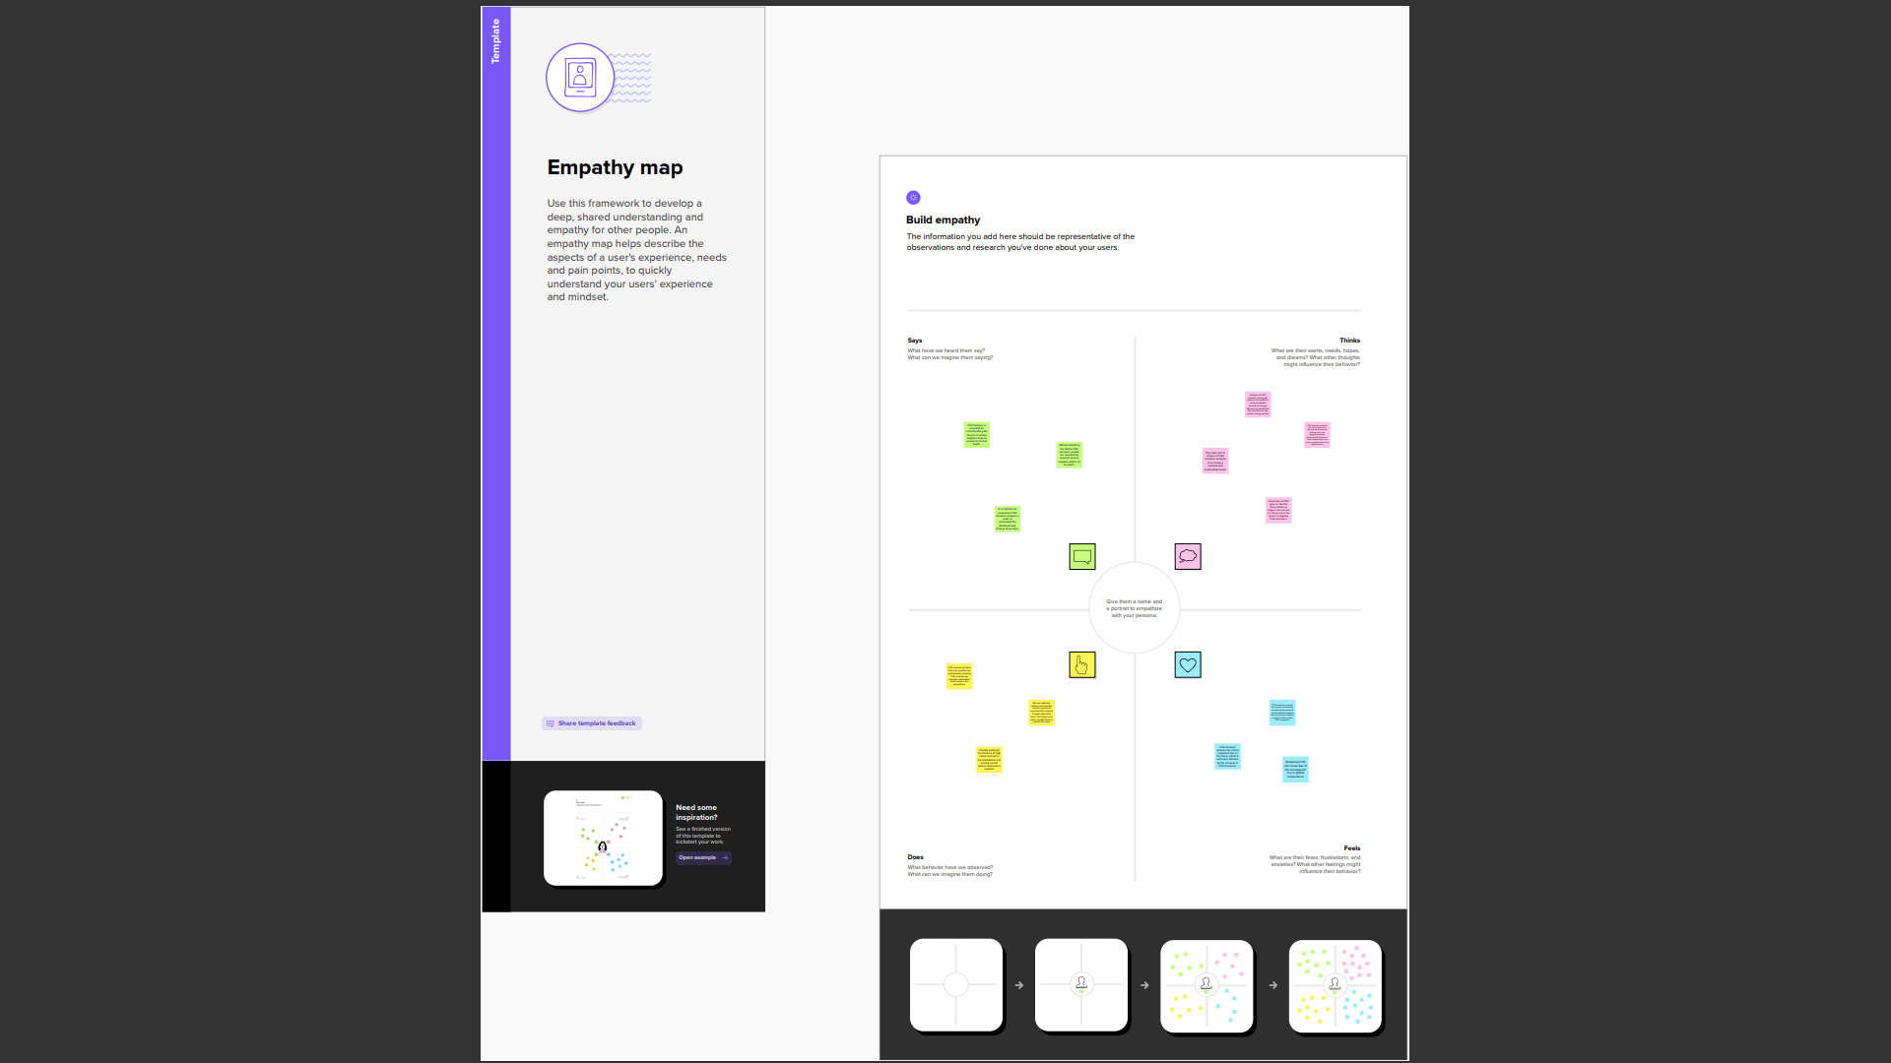

2.2 Ideation & Brainstorming Map:

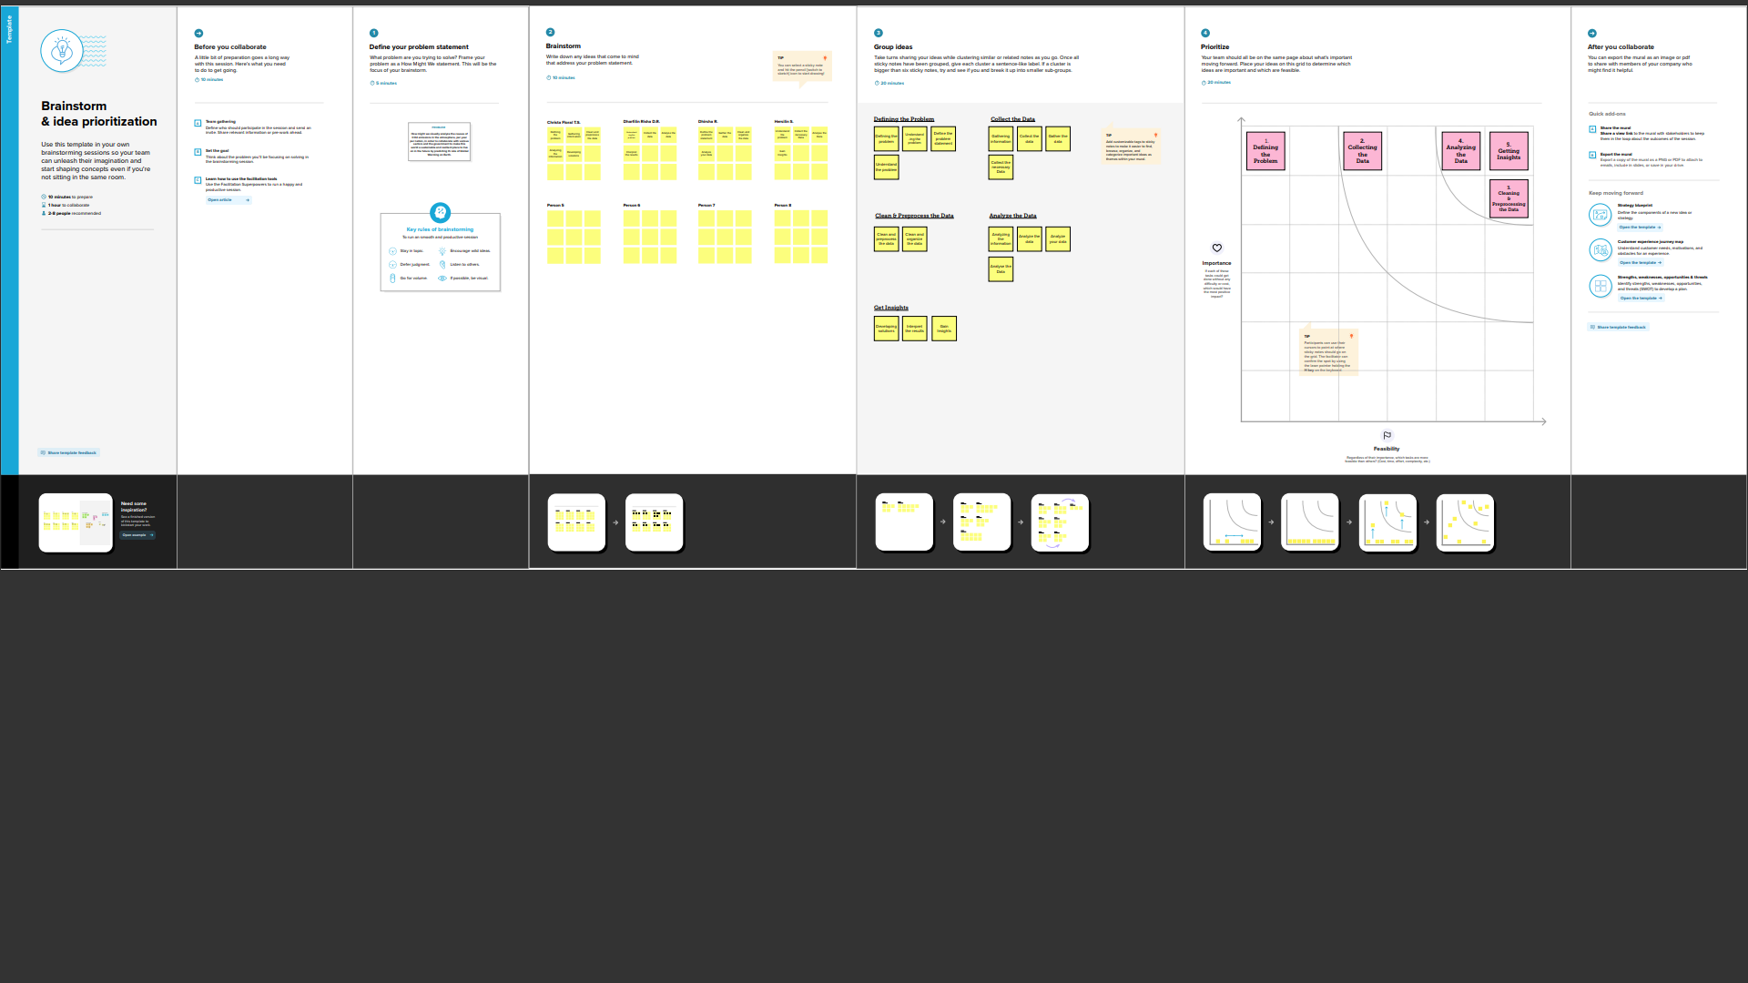

1. Result:

The Screenshots of Global CO2 Emission Analysis Dashboards-

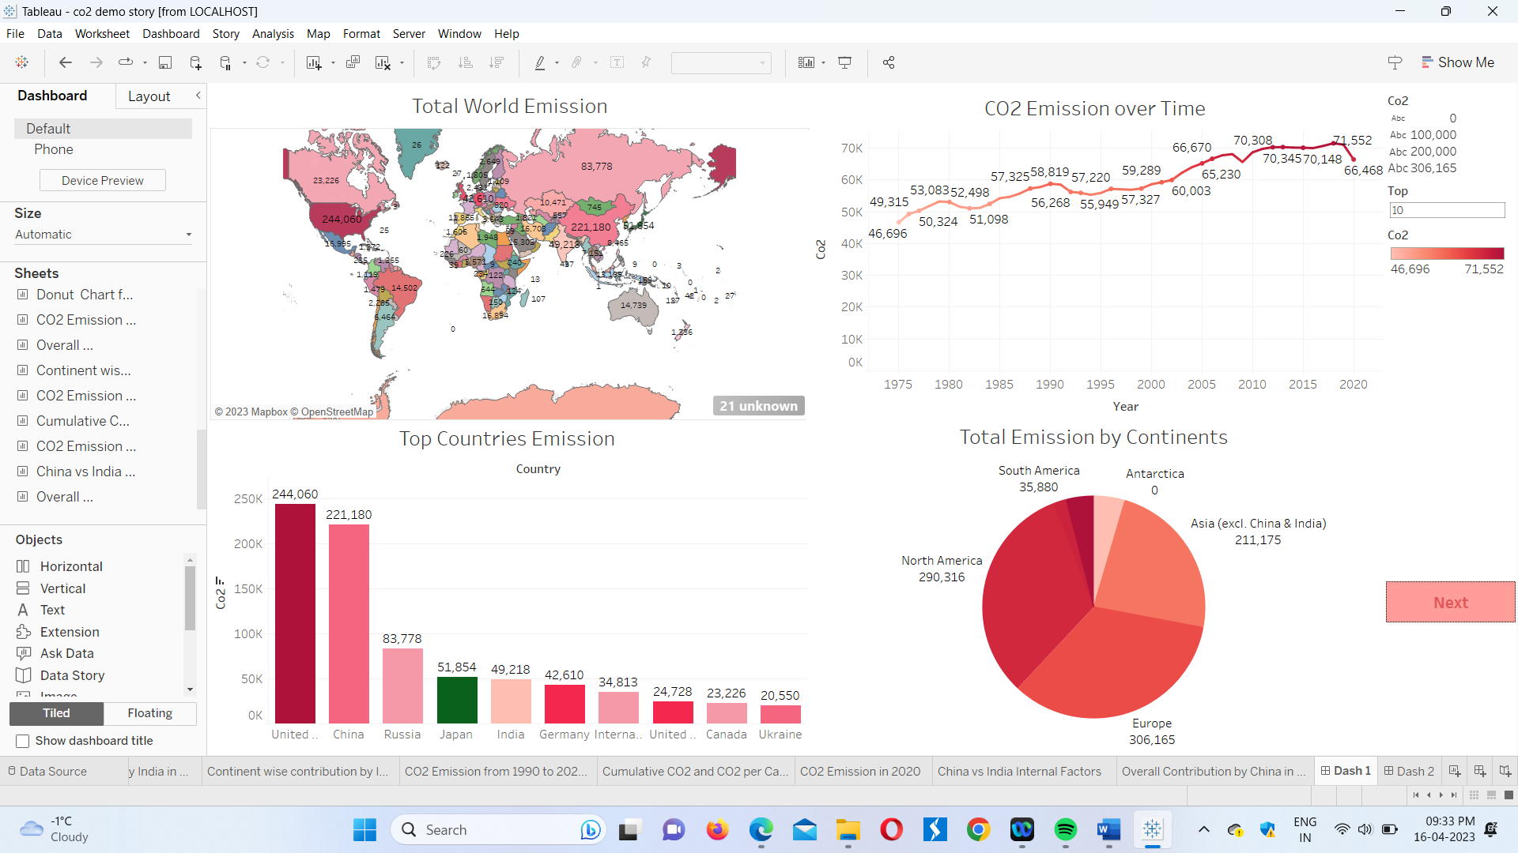

The above screenshot is the dashboard, dash 1 which displays the visualisations of

* the Total Global CO2 Emission,
* how the Global Co2 Emission has increased over time for the past years (1975-2020),
* the United States being the top most country which emits the highest amount of CO2 globally,
* also, that among the continents of the world, Europe emits higher amount of CO2.

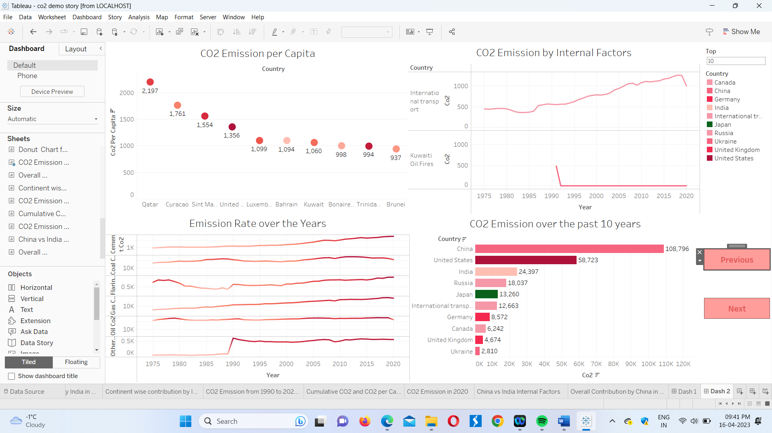

This is the screenshot of Dash 2 which shows us the increase in the global CO2 emission due to Coal, cement, flaring, gas, oil and other industrial causes over the past years, i.e., from 1975 to 2020.

Over the past 10 years, the Global CO2 emission has increased drastically in China and India stands 3rd in the list of the Top 10 countries.

Comparison of India with China, a country with stands first for highest Global CO2 emission over the past 10 years.

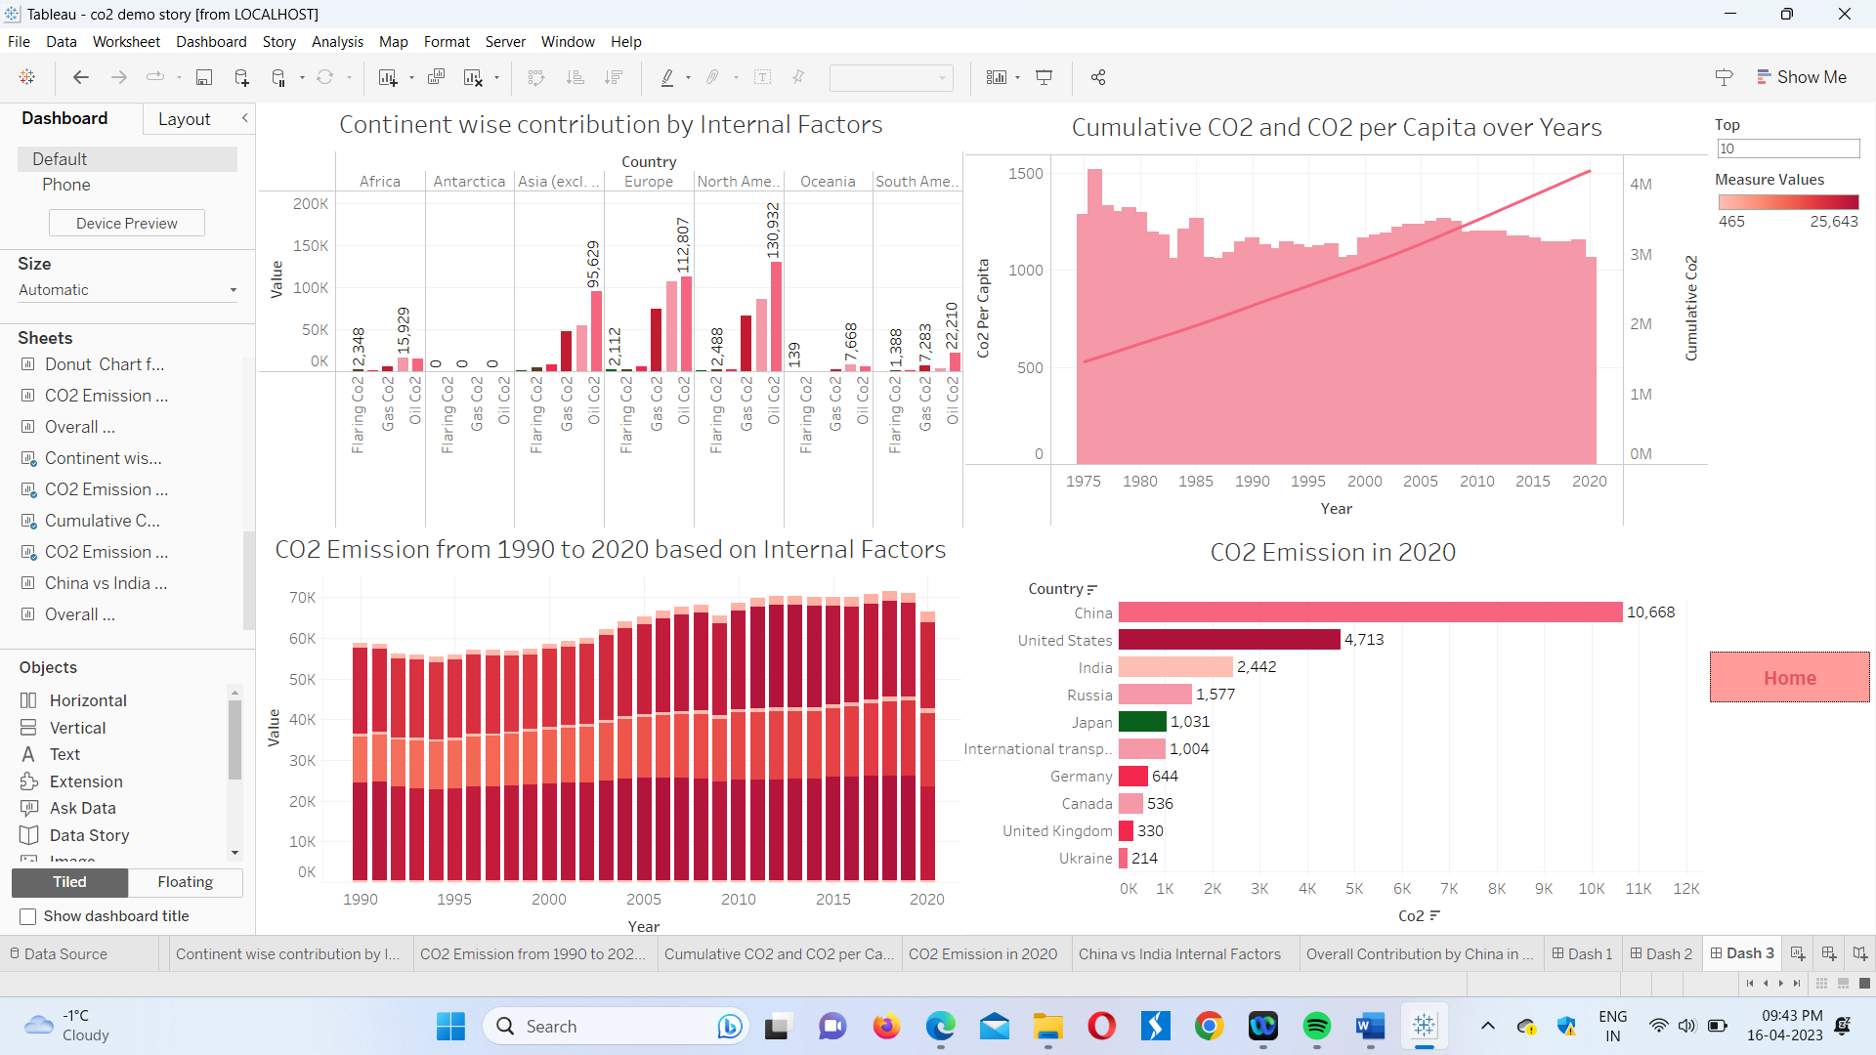

This is the screenshot of dash 3 which shows us that the CO2 Emission from 1990 to 2020 based on internal factors is graphically represented by a Bar graph.

And the Cumulative CO2 and CO2 per capita over years is depicted by a bar and a line graph respectively.

Though India’s position in these visualisations seems to be less threatening when compared to United states or China but we still take the top positions for emitting high CO2 globally. And also Coal happens to be the source of highest Global Co2 emissions

CO2 Emission Analysis Story screenshots

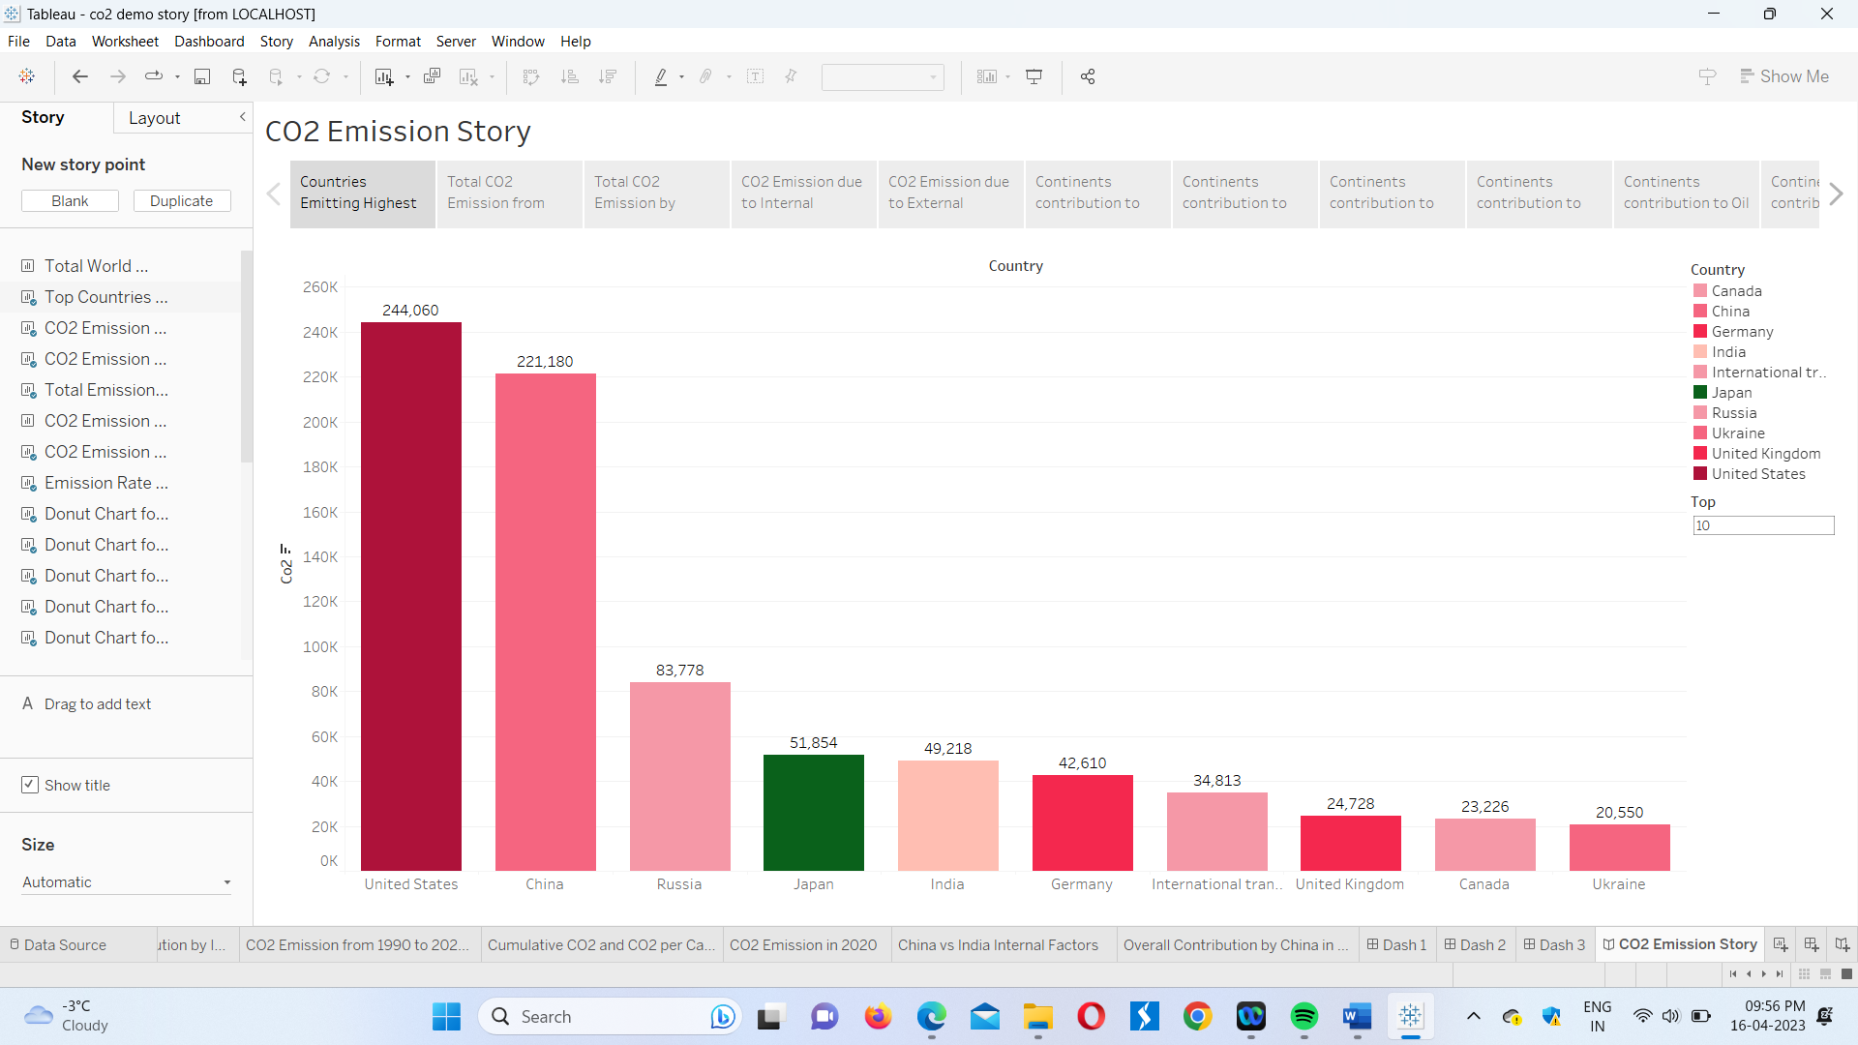

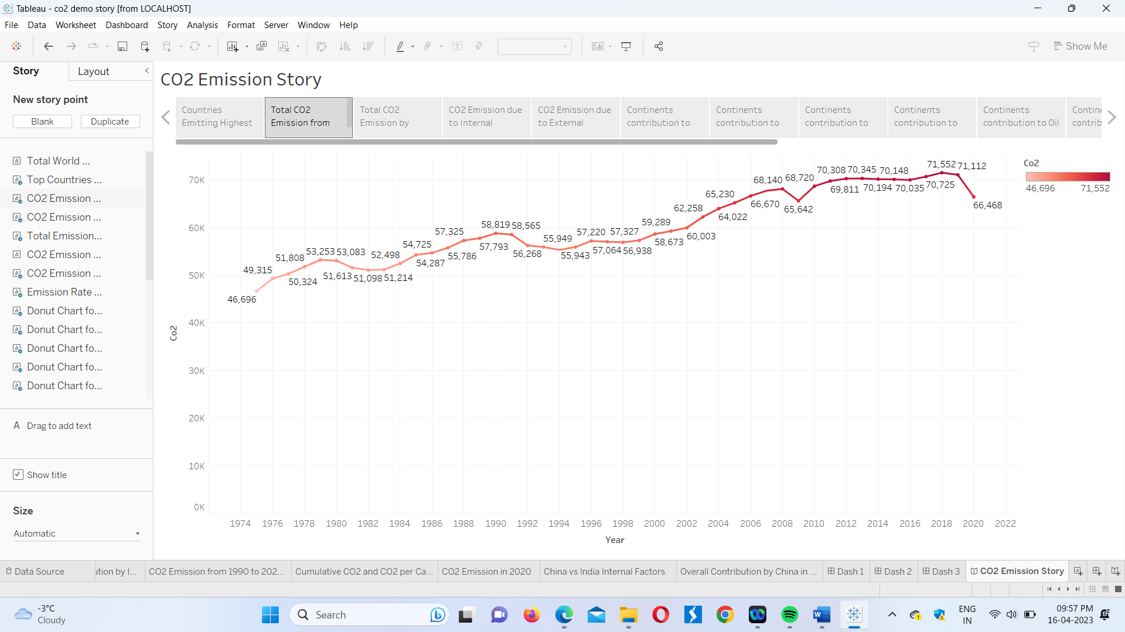

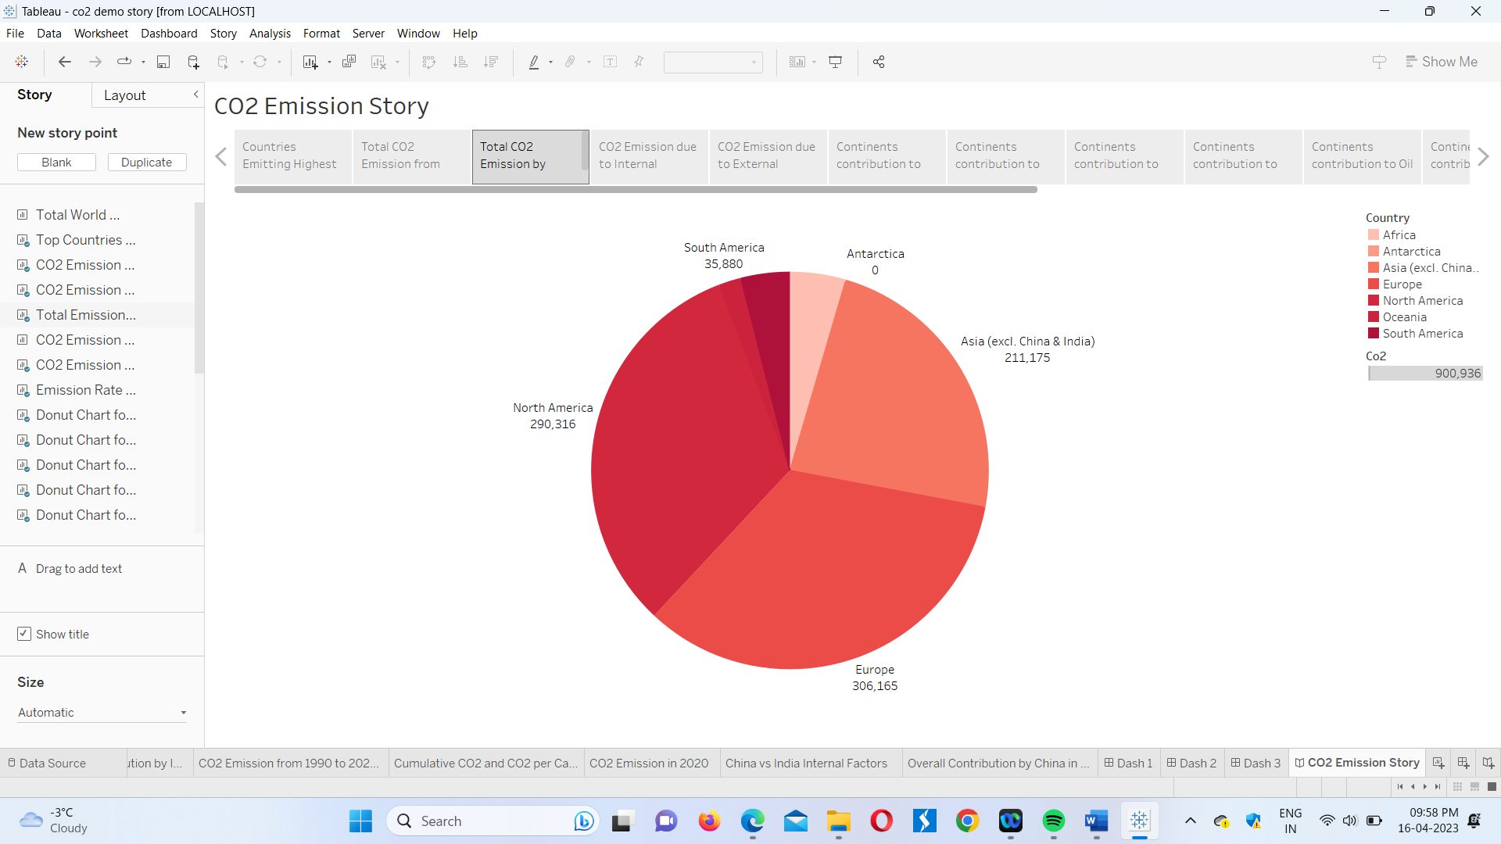

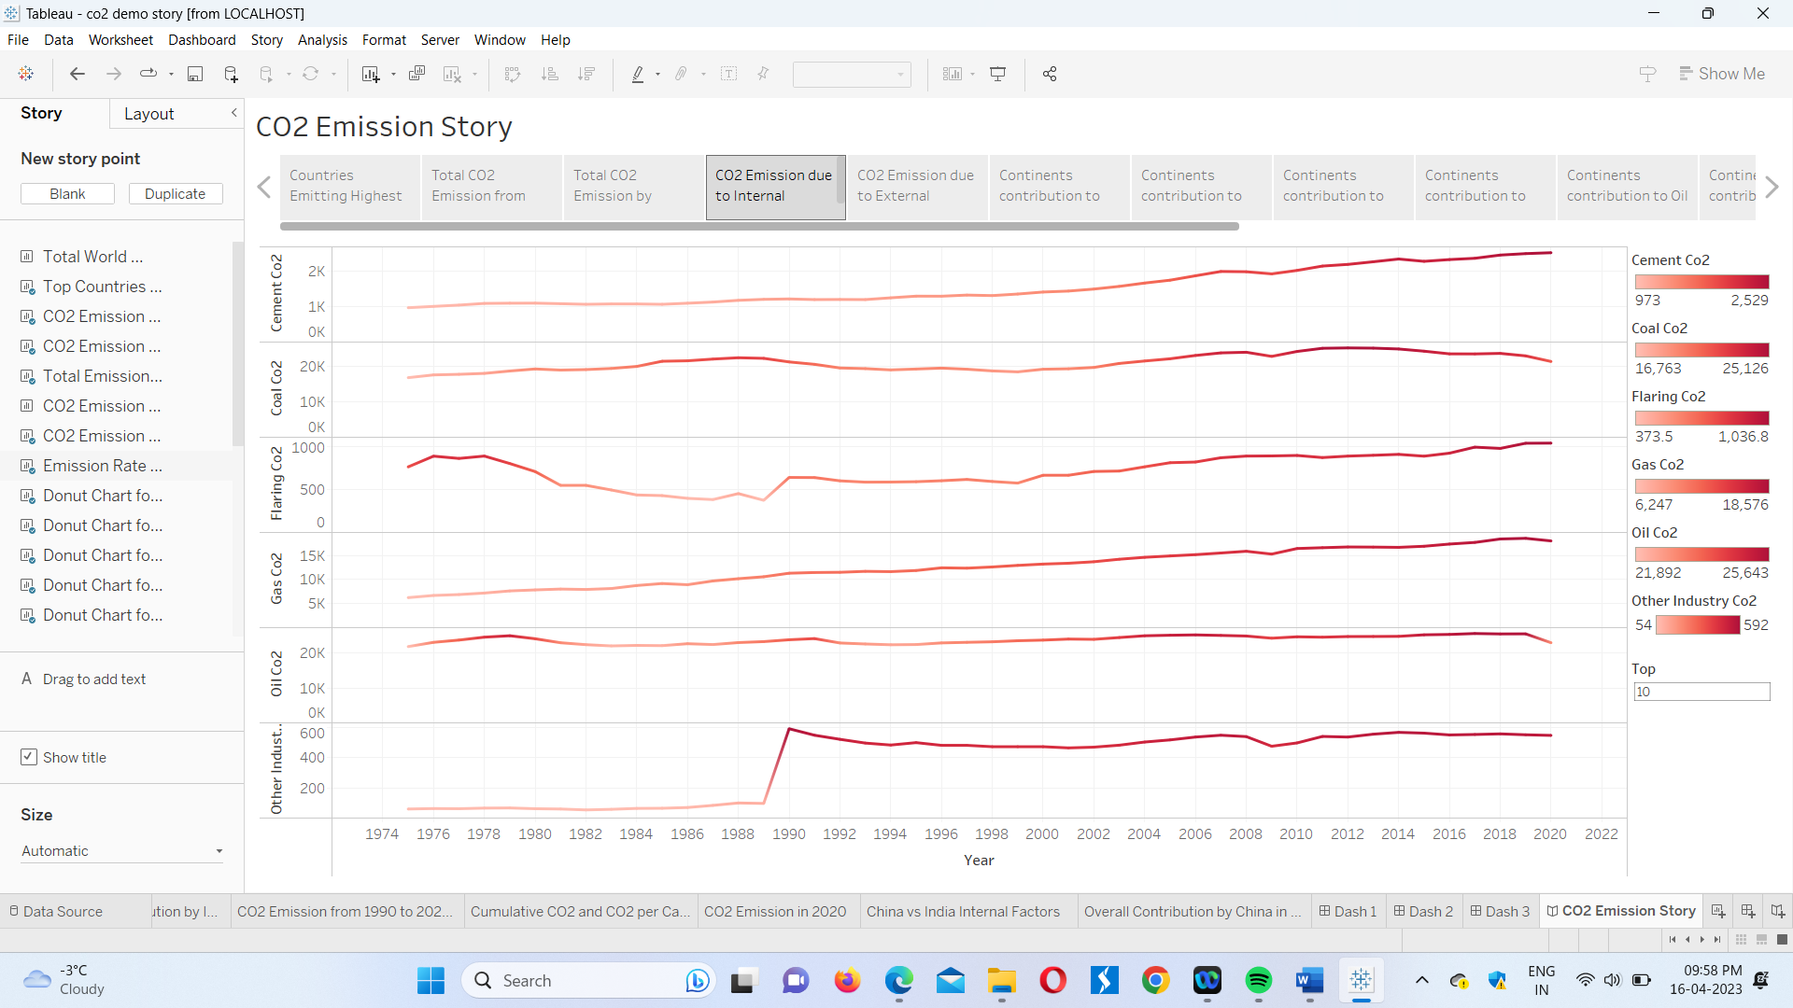

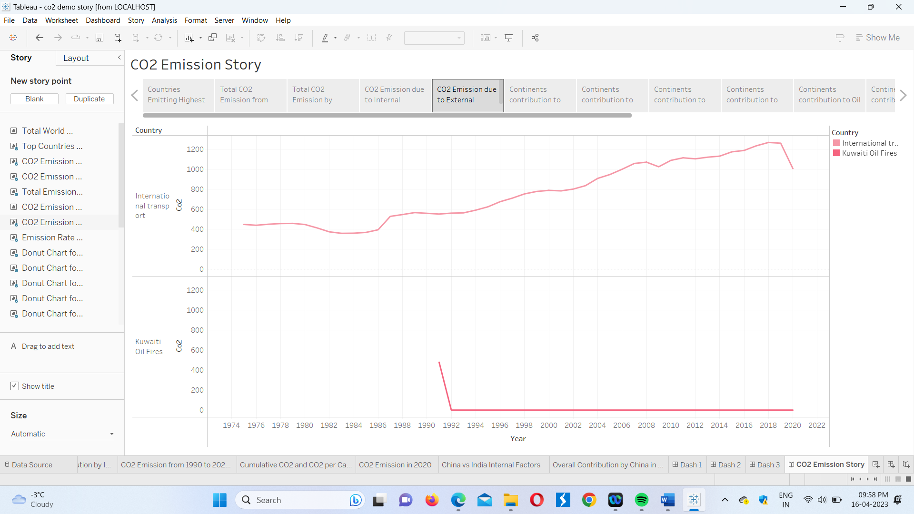

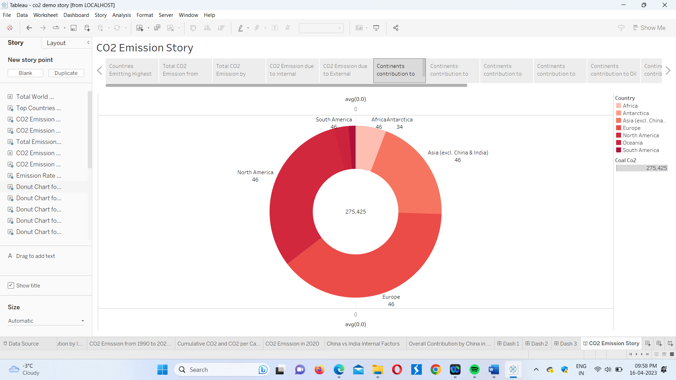

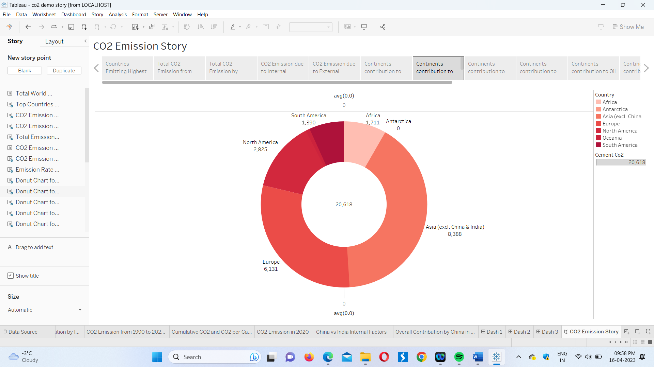

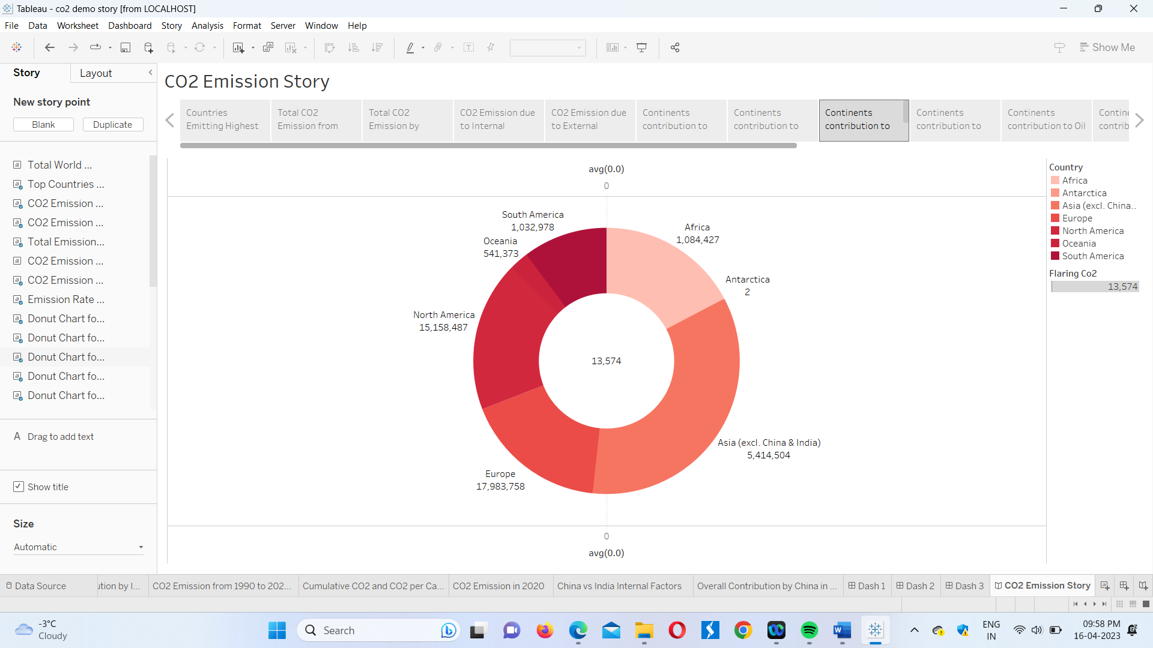

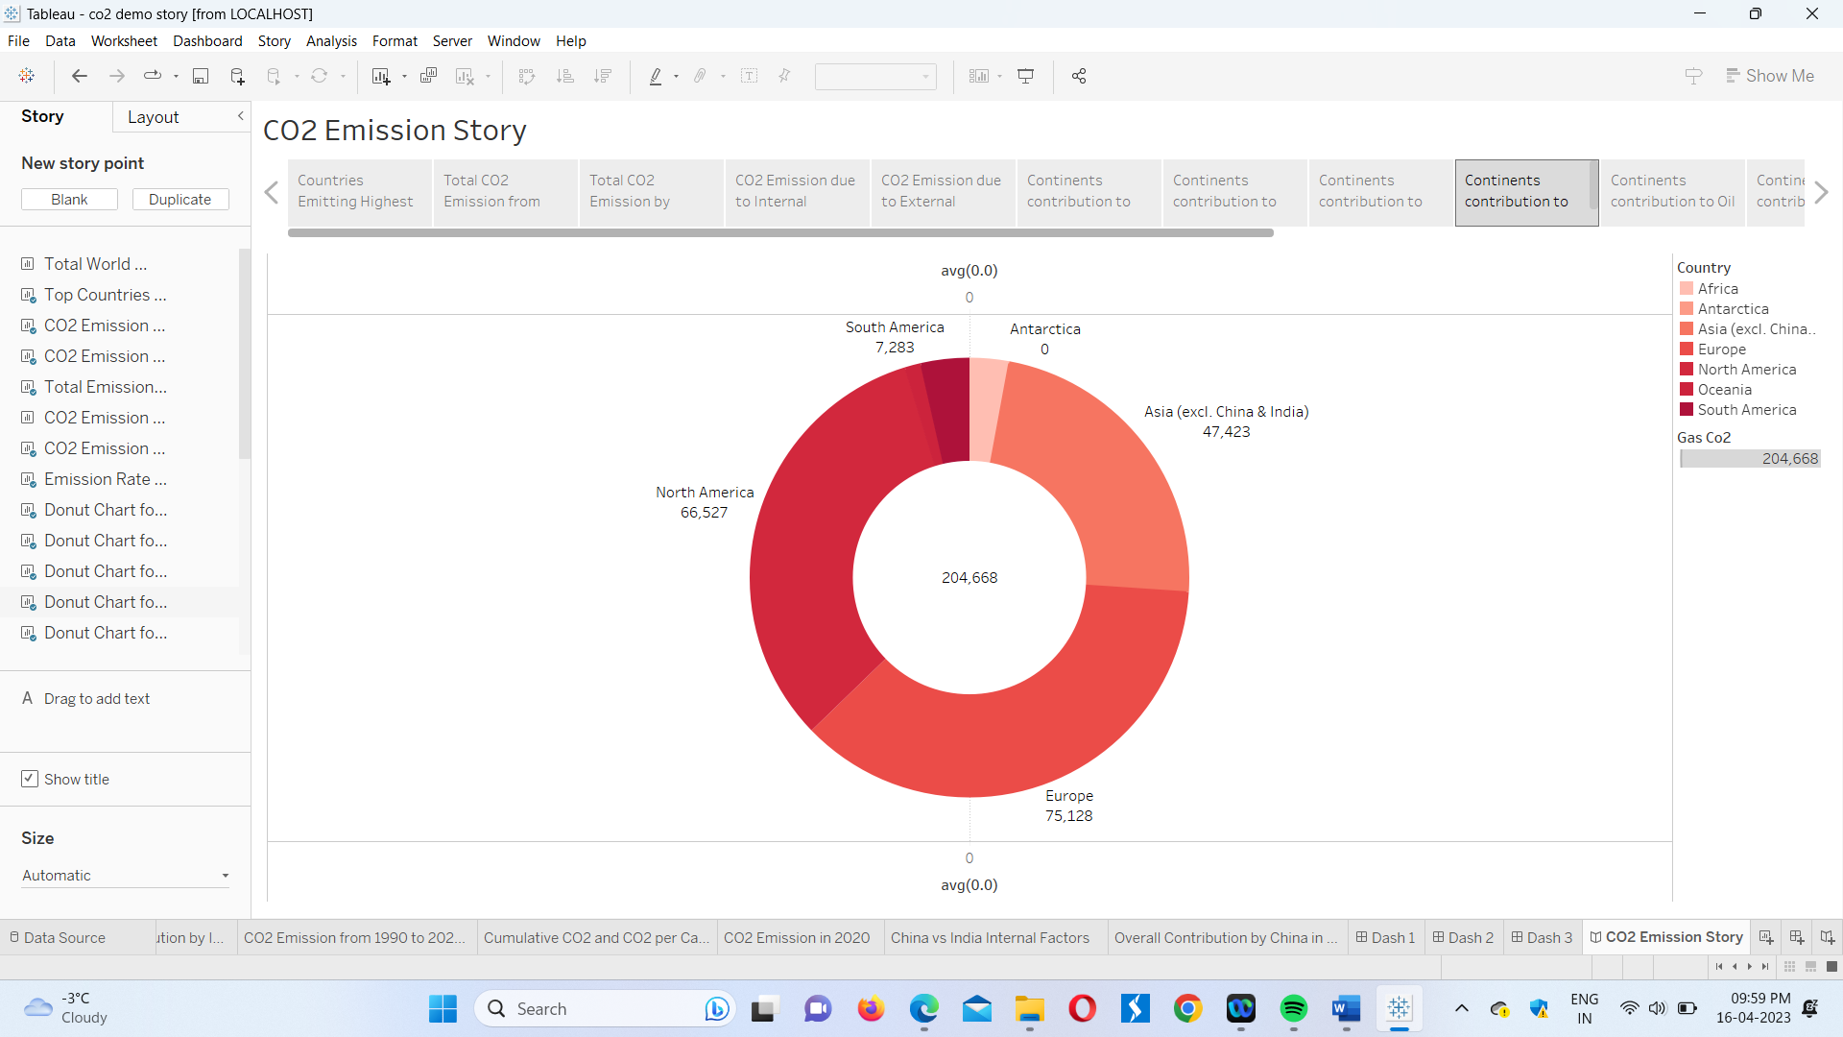

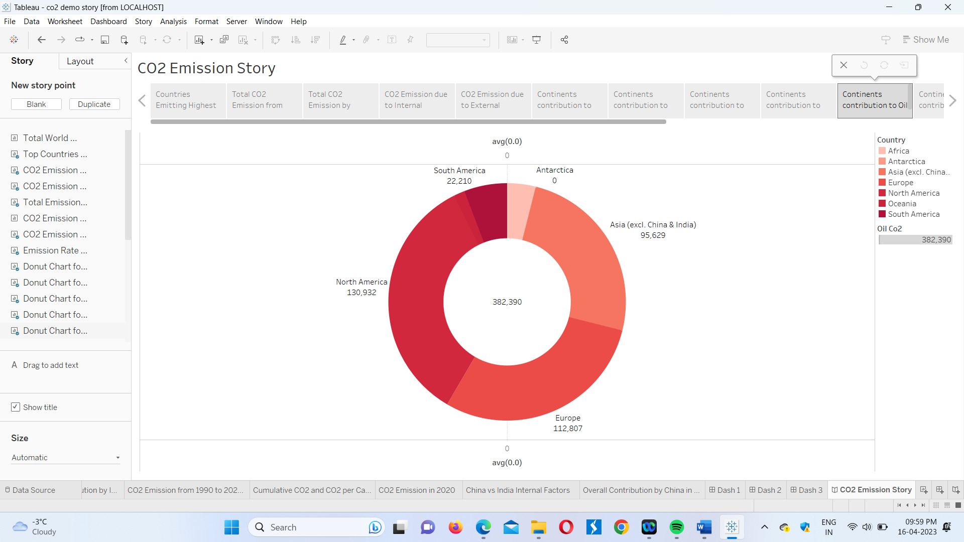

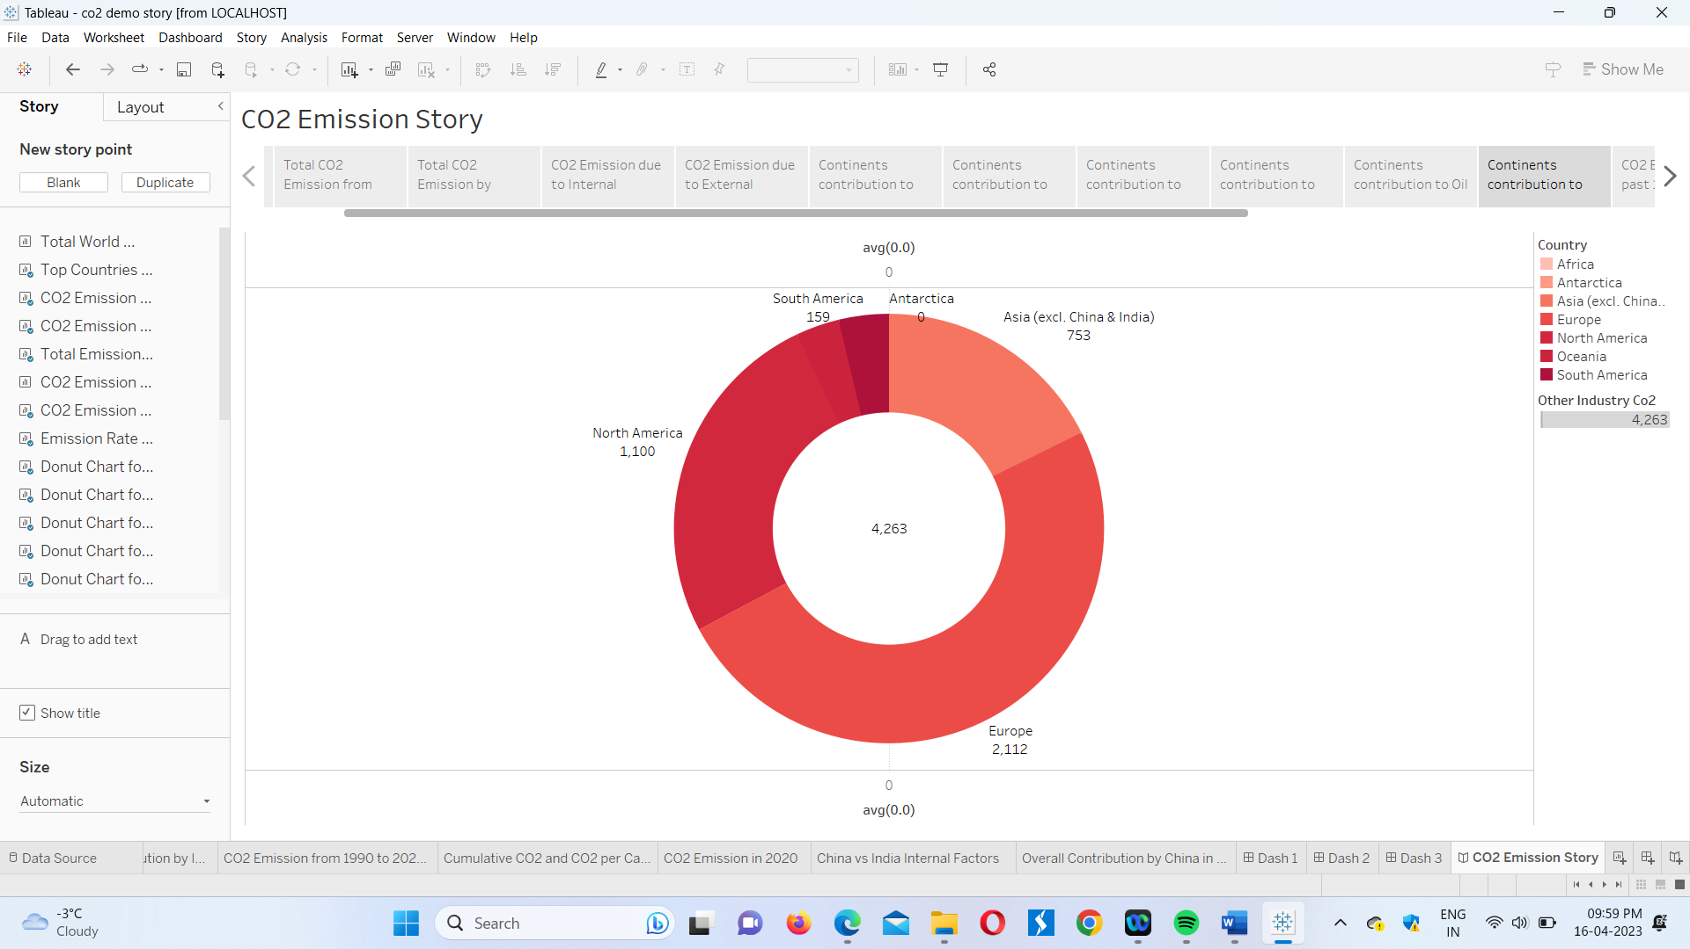

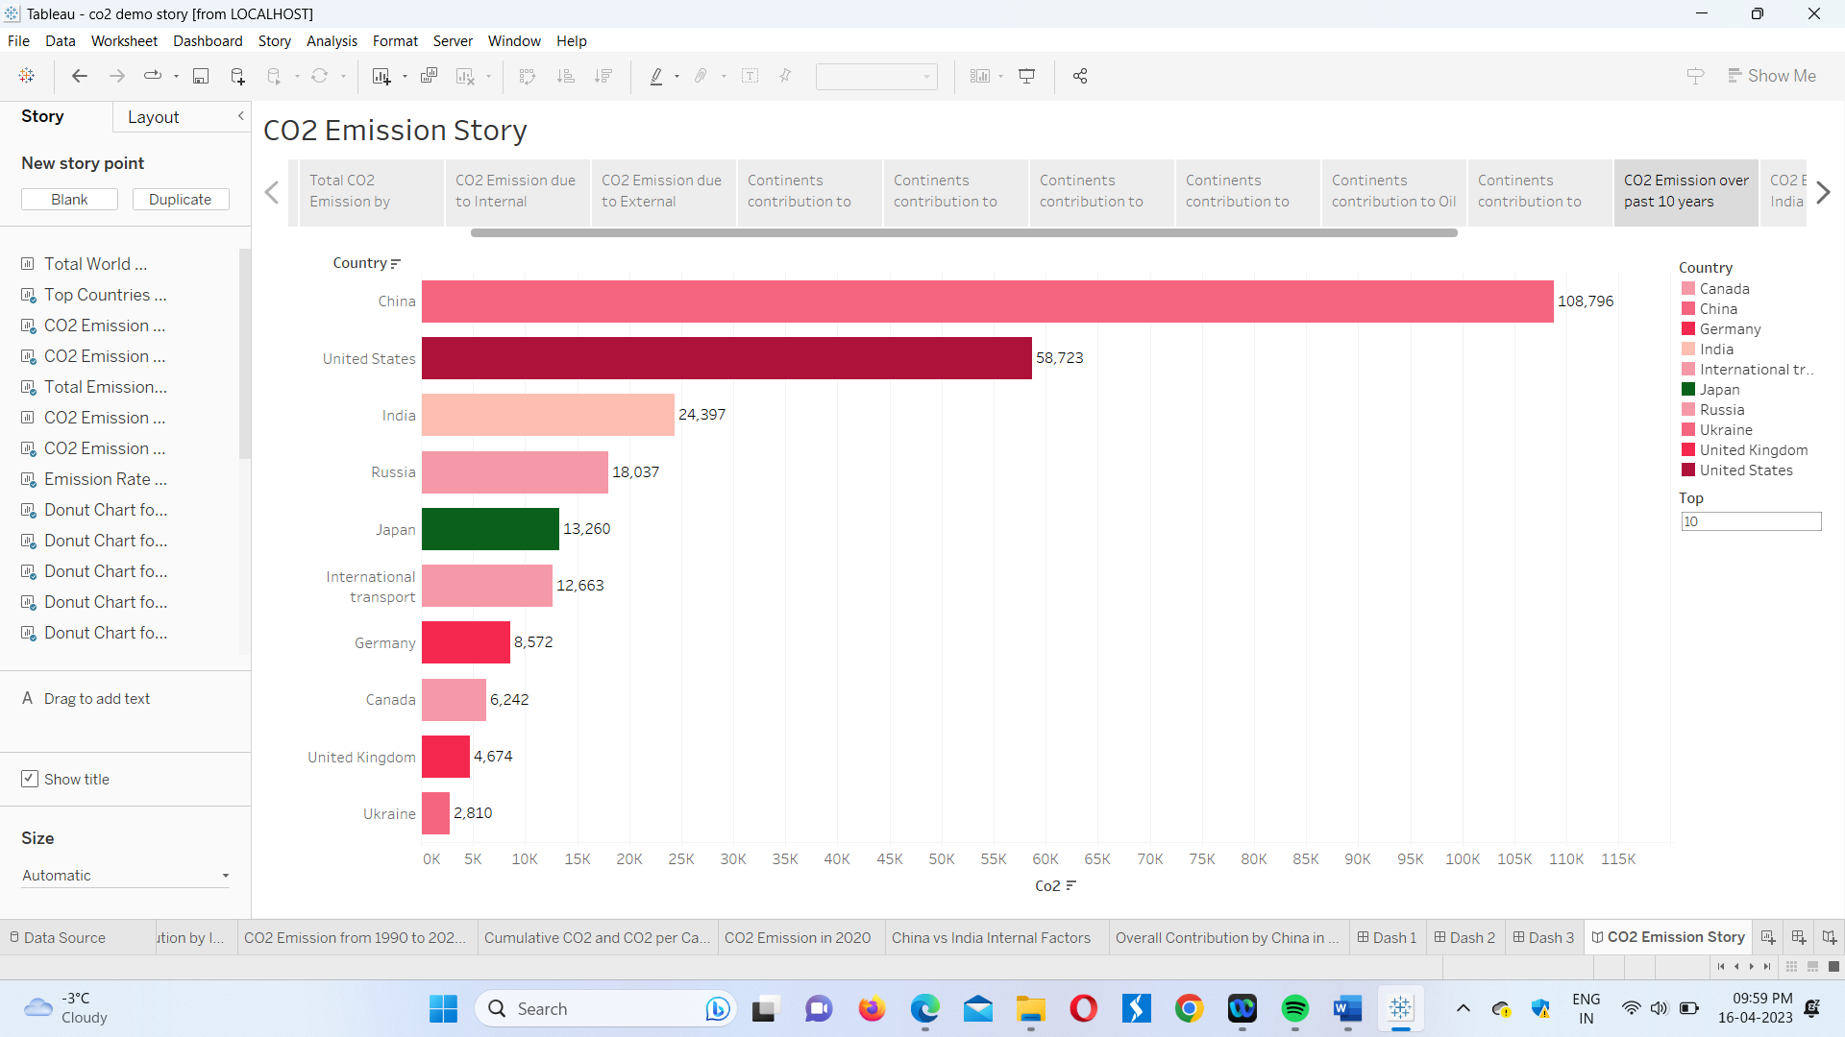

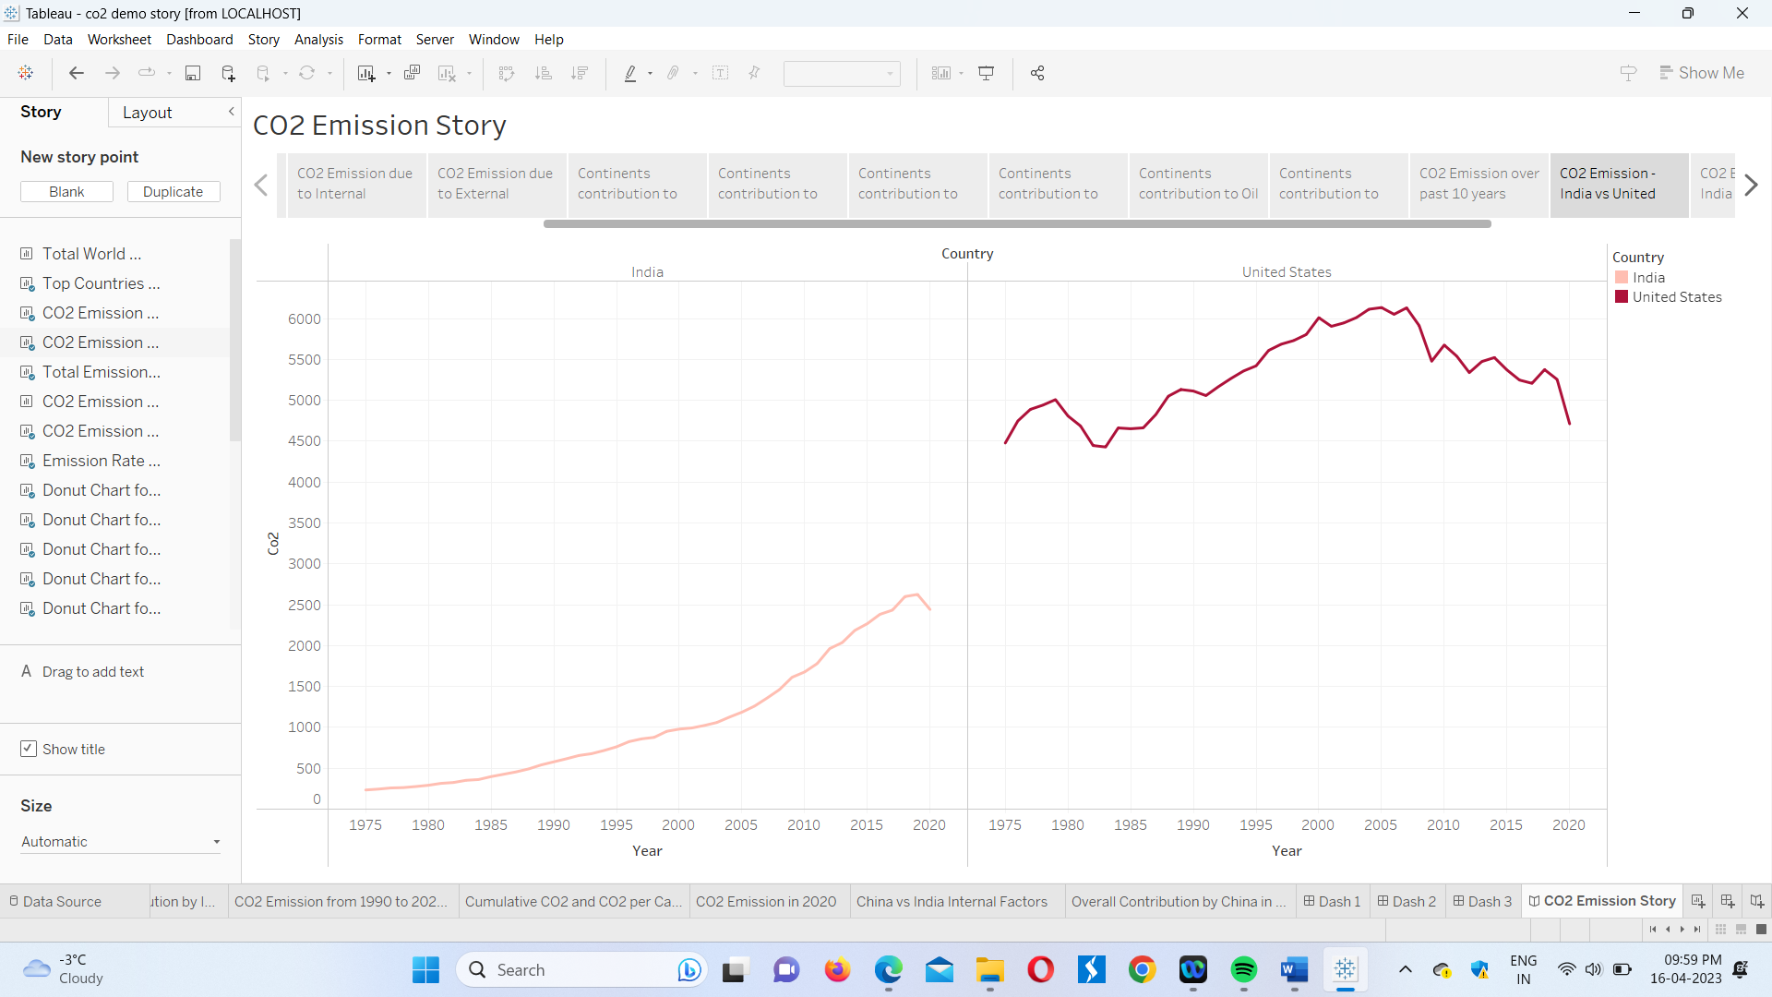

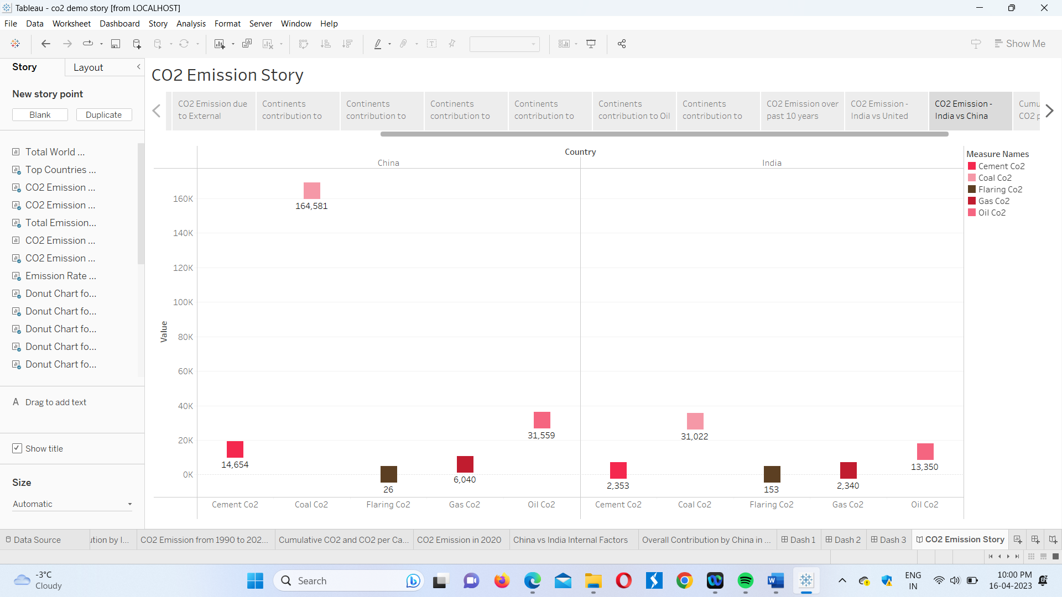

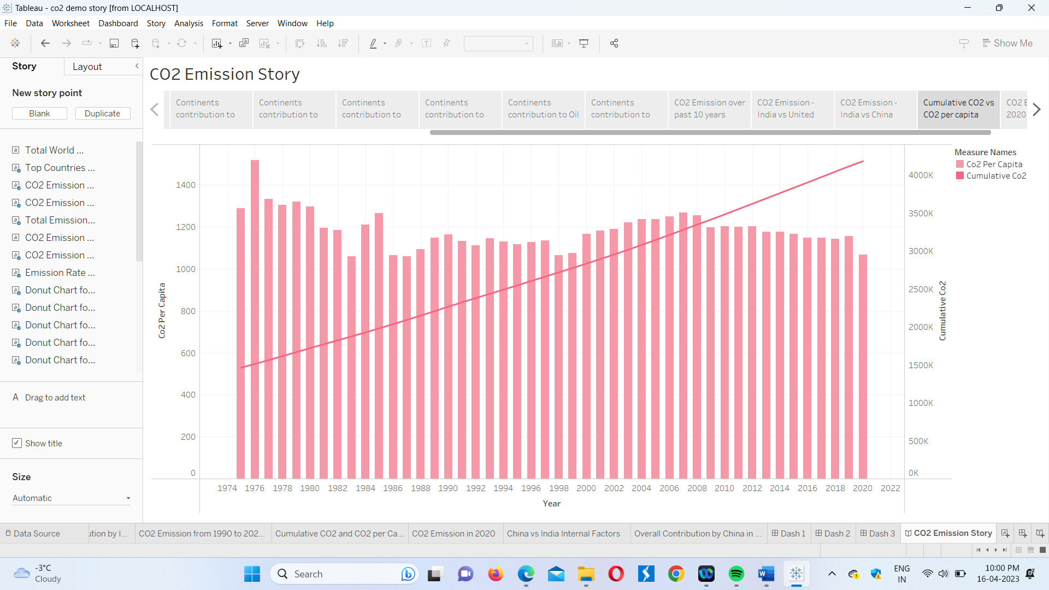

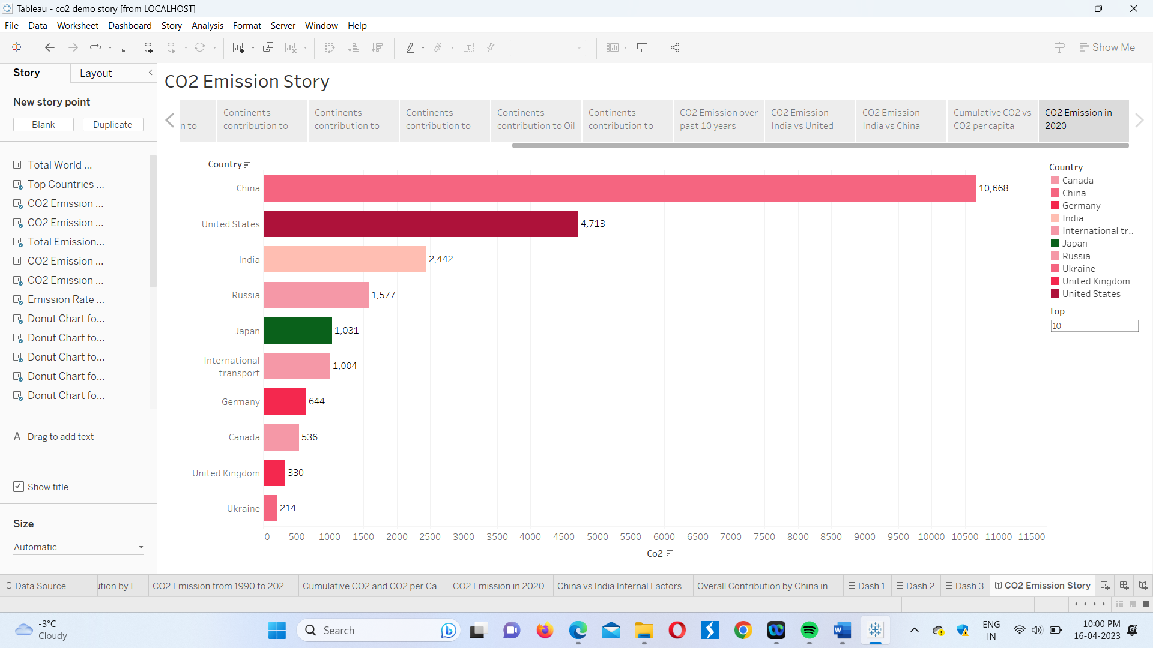

The Screenshots of the Webpage-

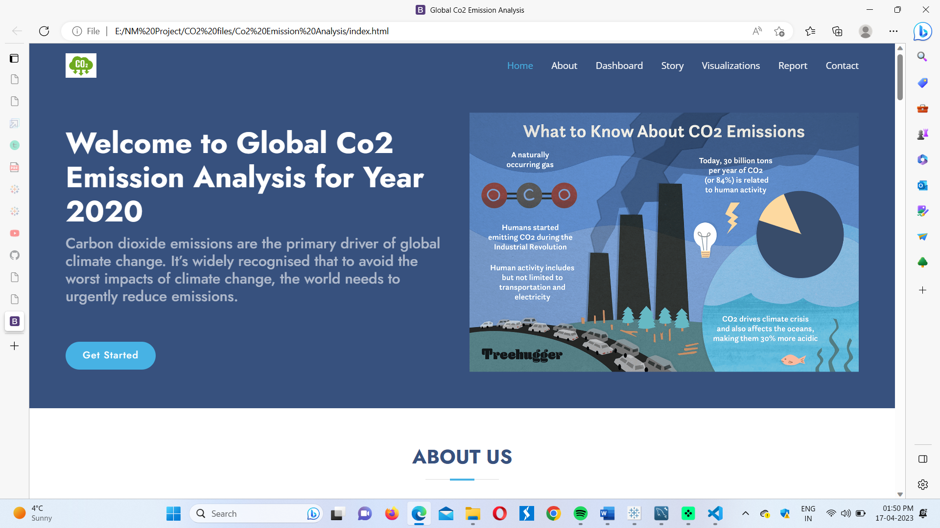

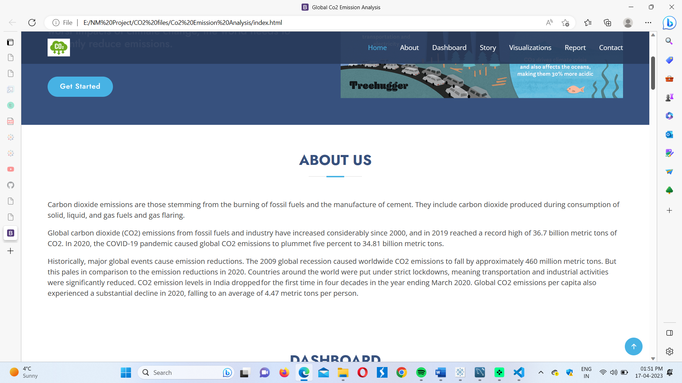

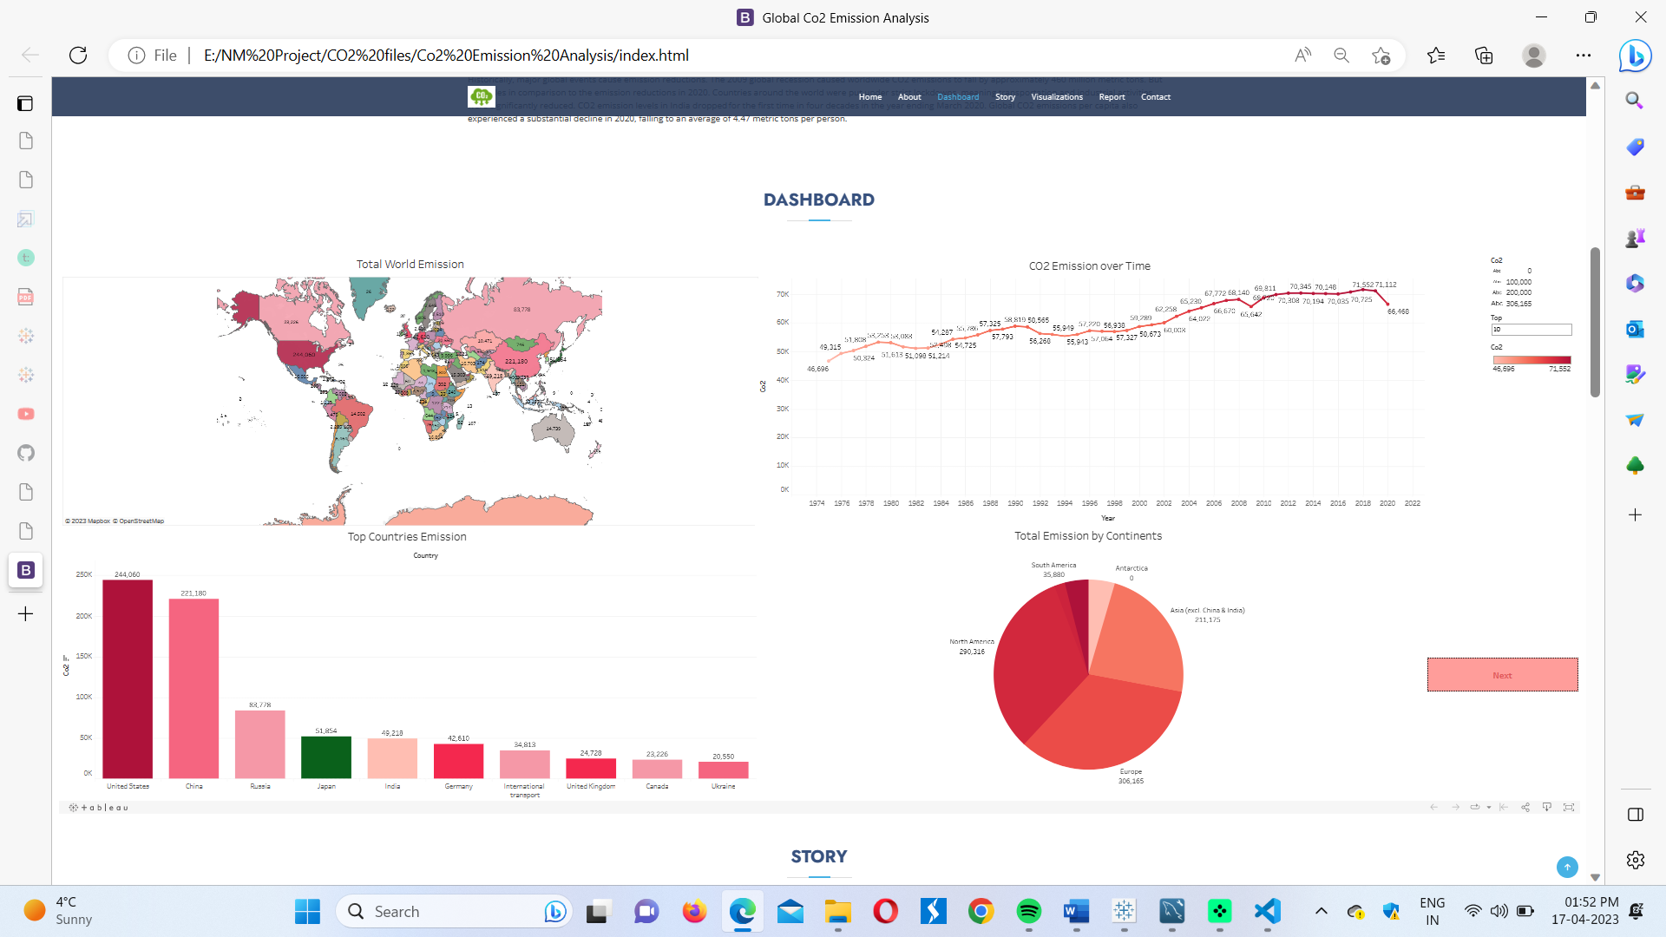

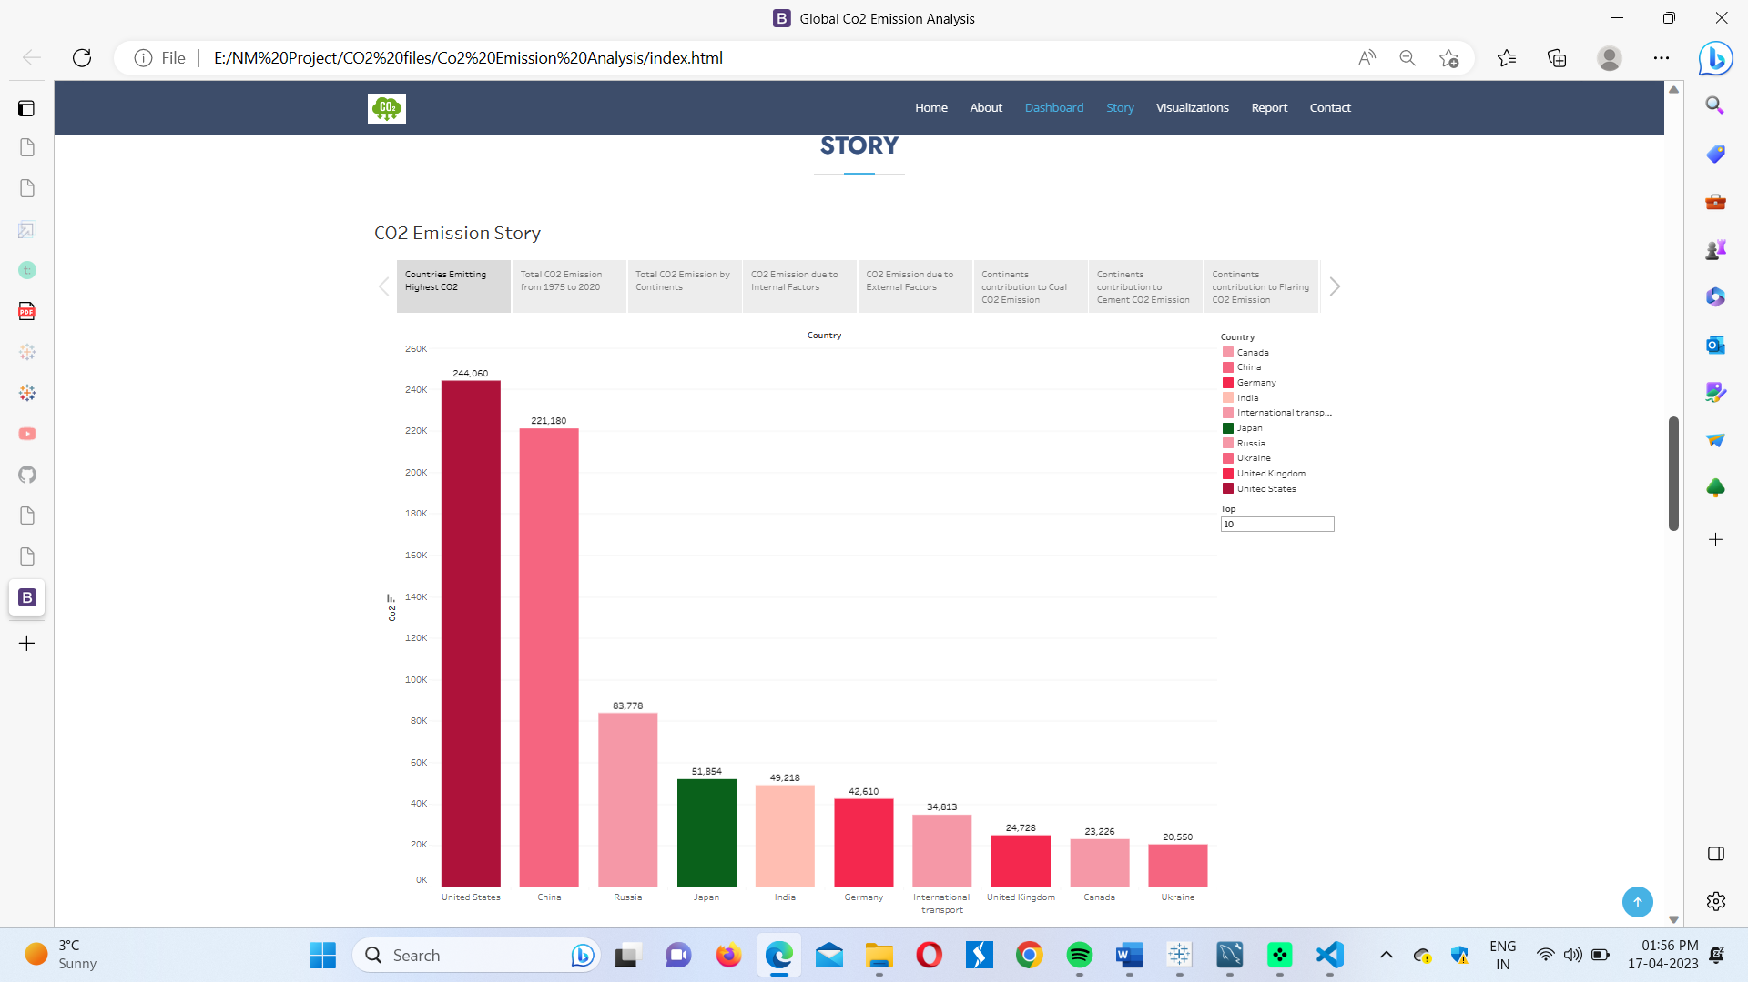

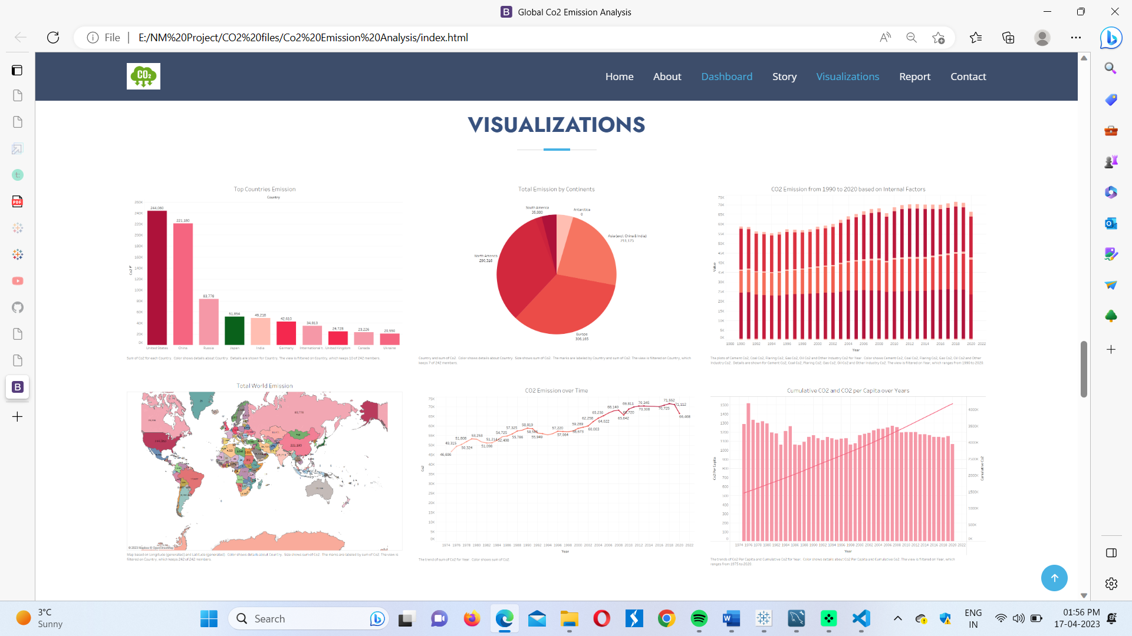

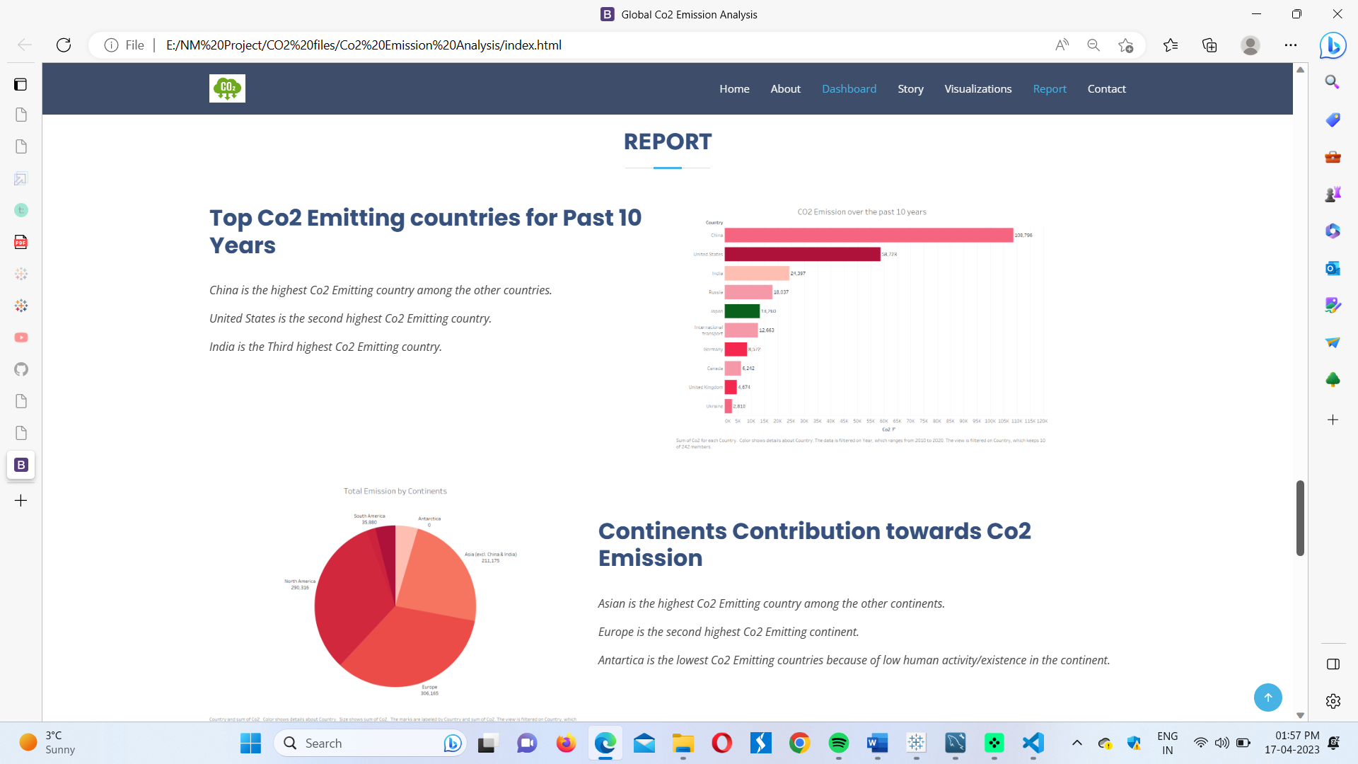

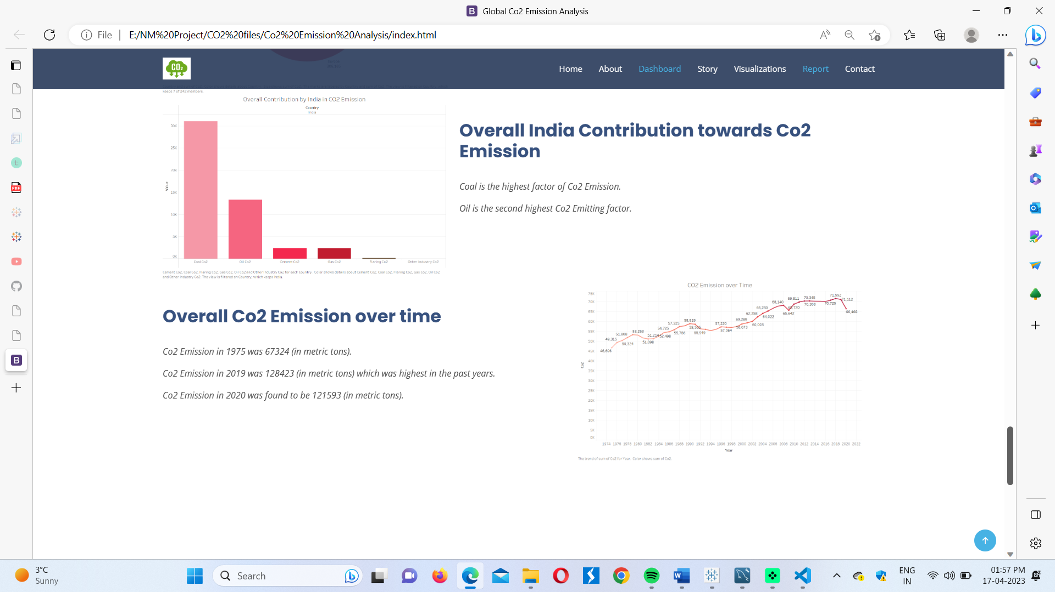

1. Advantages & Disadvantages:

When we analyse the Global CO2 Emission, we can clearly notice that CO2 is mostly emitted due to the use of Oil and Coal in most of the Continents. Even in India, CO2 emission is mainly affected by the usage of Coal. Therefore, obviously reducing the use of Coal and Oil is the only solution to control CO2 emission globally, which in turn would reduce the Global Warming as a whole.

Now when we come to the advantages and disadvantages of this solution, we have to lay light on few of the points.

Firstly, the **advantages** of this particular solution. Reducing the usage of coal and oil can help us in the following ways. They are:

1. reduces the rate and pace at which the global warming is taking place.
2. It can result in a cleaner and safer environment by improving the air quality.
3. Coal and oil usage can have taken a greater toll on deteriorating our health. By reducing the usage of coal, we are improving our health.

Now let’s take a look at the **disadvantages** of reducing

Coal and oil. They are:

1. Reducing coal usage can cause negative impacts on the economic sector.
2. Cutting down coal and oil can cause an unreliability in the steady supply of energy sources, since they are a traditional source of energy.
3. Coal is one of the cheapest sources of energy. Therefore, cutting of coal and oil can increase the cost of regular living of a person.
4. Finding an alternative for coal and oil is a challenge as a whole.
5. Applications:

The areas where reducing coal and oil can be applied is:

* In generation of electricity
* In transportation
* In industries
* In agriculture, for irrigation, transportation and processing
* In households

These are a few of the important areas in which reduction of coal and oil must be applied to.

1. Conclusion:

Thus, through this project we can conclude that the major cause for the increase in global CO2 emission is the use of Coal and oil mainly. This project has clearly pin pointed us that being careless can result in India being the 1st country responsible for the increase in the global CO2 emission and it is in our hands to understand that and to take necessary steps in reducing the same. By our findings, we truly believe that reducing the use of coal and oil will surely reduce the CO2 emission and which in turn would reduce the raising greenhouse effects.

The government and even us, the humans should take small-small steps towards decreasing this at least on the yearly basis.

1. Future Scope:

Join us in our mission to combat climate change by taking a closer look at the Global CO2 emission data visualisations and uncovering insights that will drive actionable change foe a better future.

* Energy efficiency optimization: we can use data analytics to analyse energy consumption pattern. Analysing this would help us to reduce the use of energy, which in turn would help us to reduce the Greenhouse Gas emissions.
* Climate Modelling: Data Analytics can be further used to analyse the changes in the climate of a place with respect to the increase in CO2 Emissions.

1. Appendix:

The Source code for our Project’s Web Applications is

<!DOCTYPE html>

<html lang="en">

<head>

    <meta charset="utf-8">

    <meta content="width=device-width, initial-scale=1.0" name="viewport">

    <title>Global Co2 Emission Analysis</title>

    <meta content="" name="description">

    <meta content="" name="keywords">

    <!-- Favicons -->

    <link href="assets/img/favicon.png" rel="icon">

    <link href="assets/img/apple-touch-icon.png" rel="apple-touch-icon">

    <!-- Google Fonts -->

    <link href="https://fonts.googleapis.com/css?family=Open+Sans:300,300i,400,400i,600,600i,700,700i|Jost:300,300i,400,400i,500,500i,600,600i,700,700i|Poppins:300,300i,400,400i,500,500i,600,600i,700,700i" rel="stylesheet">

    <!-- Vendor CSS Files -->

    <link href="assets/vendor/aos/aos.css" rel="stylesheet">

    <link href="assets/vendor/bootstrap/css/bootstrap.min.css" rel="stylesheet">

    <link href="assets/vendor/bootstrap-icons/bootstrap-icons.css" rel="stylesheet">

    <link href="assets/vendor/boxicons/css/boxicons.min.css" rel="stylesheet">

    <link href="assets/vendor/glightbox/css/glightbox.min.css" rel="stylesheet">

    <link href="assets/vendor/remixicon/remixicon.css" rel="stylesheet">

    <link href="assets/vendor/swiper/swiper-bundle.min.css" rel="stylesheet">

    <!-- Template Main CSS File -->

    <link href="assets/css/style.css" rel="stylesheet">

    <!-- =======================================================

  * Template Name: Arsha - v4.10.0

  * Template URL: https://bootstrapmade.com/arsha-free-bootstrap-html-template-corporate/

  * Author: BootstrapMade.com

  * License: https://bootstrapmade.com/license/

  ======================================================== -->

</head>

<body>

    <!-- ======= Header ======= -->

    <header id="header" class="fixed-top ">

        <div class="container d-flex align-items-center justify-content-between">

            <h1 class="logo"><img src="https://media.istockphoto.com/id/1323550608/vector/co2-reduction-cloud-eco-vector-icon.jpg?s=612x612&w=0&k=20&c=jO3OZfYAg9gB8TWvzH8BR64Lq3pFrfHcOvxpSgB-cjA="> </h1>

            <!-- Uncomment below if you prefer to use an image logo -->

            <!-- <a href="index.html" class="logo me-auto"><img src="assets/img/logo.png" alt="" class="img-fluid"></a>-->

            <nav id="navbar" class="navbar">

                <ul>

                    <li><a class="nav-link scrollto active" href="#hero">Home</a></li>

                    <li><a class="nav-link scrollto" href="#about">About</a></li>

                    <li><a class="nav-link scrollto" href="#dash">Dashboard</a></li>

                    <li><a class="nav-link scrollto" href="#services">Story</a></li>

                    <li><a class="nav-link scrollto" href="#portfolio">Visualizations</a></li>

                    <li><a class="nav-link scrollto" href="#report">Report</a></li>

                    <li><a class="nav-link scrollto" href="#contact">Contact</a></li>

                </ul>

                <i class="bi bi-list mobile-nav-toggle"></i>

            </nav>

            <!-- .navbar -->

        </div>

    </header>

    <!-- End Header -->

    <!-- ======= Hero Section ======= -->

    <section id="hero" class="d-flex align-items-center">

        <div class="container">

            <div class="row">

                <div class="col-lg-6 d-flex flex-column justify-content-center pt-4 pt-lg-0 order-2 order-lg-1" data-aos="fade-up" data-aos-delay="200">

                    <h1>Welcome to Global Co2 Emission Analysis for Year 2020</h1>

                    <h2>Carbon dioxide emissions are the primary driver of global climate change. It’s widely recognised that to avoid the worst impacts of climate change, the world needs to urgently reduce emissions.</h2>

                    <div class="d-flex justify-content-center justify-content-lg-start">

                        <a href="#about" class="btn-get-started scrollto">Get Started</a>

                        <a href="https://www.youtube.com/watch?v=jDDaplaOz7Q" class="glightbox btn-watch-video"></a>

                    </div>

                </div>

                <div class="col-lg-6 order-1 order-lg-2 hero-img" data-aos="zoom-in" data-aos-delay="200">

                    <img src="https://www.treehugger.com/thmb/LbdMV9gbfA1S7Y3SB0XhlSl4EFw=/1500x0/filters:no_upscale():max_bytes(150000):strip_icc()/co-why-is-carbon-dioxide-bad-4864246_V2-4ea7c0936b5a4cd3b8d4f2b41ec02f63.png" class="img-fluid animated" alt="">

                </div>

            </div>

        </div>

    </section>

    <!-- End Hero -->

    <main id="main">

        <!-- ======= Clients Section ======= -->

        <!-- End Cliens Section -->

        <!-- ======= About Us Section ======= -->

        <section id="about" class="about">

            <div class="container">

                <div class="section-title">

                    <h2>About Us</h2>

                </div>

                <div class="row content">

                    <div class="col-lg-12">

                        <p>

                            Carbon dioxide emissions are those stemming from the burning of fossil fuels and the manufacture of cement. They include carbon dioxide produced during consumption of solid, liquid, and gas fuels and gas flaring.

                        </p>

                        <p>

                            Global carbon dioxide (CO2) emissions from fossil fuels and industry have increased considerably since 2000, and in 2019 reached a record high of 36.7 billion metric tons of CO2. In 2020, the COVID-19 pandemic caused global CO2 emissions to plummet five

                            percent to 34.81 billion metric tons.</p>

                        <p> Historically, major global events cause emission reductions. The 2009 global recession caused worldwide CO2 emissions to fall by approximately 460 million metric tons. But this pales in comparison to the emission reductions in

                            2020. Countries around the world were put under strict lockdowns, meaning transportation and industrial activities were significantly reduced. CO2 emission levels in India dropped for the first time in four decades in the year

                            ending March 2020. Global CO2 emissions per capita also experienced a substantial decline in 2020, falling to an average of 4.47 metric tons per person.</p>

                    </div>

                </div>

            </div>

        </section>

        <!-- End About Us Section -->

        <!-- ======= Why Us Section ======= -->

        <section id="dash" class="">

            <div class="container-fluid" data-aos="fade-up">

                <div class="section-title">

                    <h2>Dashboard</h2>

                </div>

                <div class='tableauPlaceholder' id='viz1681718616648' style='position: relative'><noscript><a href='#'><img alt='Dash 1 ' src='https:&#47;&#47;public.tableau.com&#47;static&#47;images&#47;co&#47;co2demodash_16814962841210&#47;Dash1&#47;1_rss.png' style='border: none' /></a></noscript><object class='tableauViz'  style='display:none;'><param name='host_url' value='https%3A%2F%2Fpublic.tableau.com%2F' /> <param name='embed_code_version' value='3' /> <param name='site_root' value='' /><param name='name' value='co2demodash_16814962841210&#47;Dash1' /><param name='tabs' value='no' /><param name='toolbar' value='yes' /><param name='static_image' value='https:&#47;&#47;public.tableau.com&#47;static&#47;images&#47;co&#47;co2demodash_16814962841210&#47;Dash1&#47;1.png' /> <param name='animate_transition' value='yes' /><param name='display_static_image' value='yes' /><param name='display_spinner' value='yes' /><param name='display_overlay' value='yes' /><param name='display_count' value='yes' /><param name='language' value='en-US' /></object></div>                <script type='text/javascript'>                    var divElement = document.getElementById('viz1681718616648');                    var vizElement = divElement.getElementsByTagName('object')[0];                    if ( divElement.offsetWidth > 800 ) { vizElement.style.width='100%';vizElement.style.height=(divElement.offsetWidth*0.75)+'px';} else if ( divElement.offsetWidth > 500 ) { vizElement.style.width='100%';vizElement.style.height=(divElement.offsetWidth*0.75)+'px';} else { vizElement.style.width='100%';vizElement.style.height='1477px';}                     var scriptElement = document.createElement('script');                    scriptElement.src = 'https://public.tableau.com/javascripts/api/viz_v1.js';                    vizElement.parentNode.insertBefore(scriptElement, vizElement);                </script> </div>

            </div>

            <!-- End Why Us Section -->

            <section id="services" class="services">

                <div class="container" data-aos="fade-up">

                    <div class="section-title">

                        <h2>Story</h2>

                    </div>

                    <div class='tableauPlaceholder' id='viz1681719802859' style='position: relative'><noscript><a href='#'><img alt='CO2 Emission Story ' src='https:&#47;&#47;public.tableau.com&#47;static&#47;images&#47;48&#47;48BQFTBF3&#47;1_rss.png' style='border: none' /></a></noscript><object class='tableauViz'  style='display:none;'><param name='host_url' value='https%3A%2F%2Fpublic.tableau.com%2F' /> <param name='embed_code_version' value='3' /> <param name='path' value='shared&#47;48BQFTBF3' /> <param name='toolbar' value='yes' /><param name='static_image' value='https:&#47;&#47;public.tableau.com&#47;static&#47;images&#47;48&#47;48BQFTBF3&#47;1.png' /> <param name='animate_transition' value='yes' /><param name='display_static_image' value='yes' /><param name='display_spinner' value='yes' /><param name='display_overlay' value='yes' /><param name='display_count' value='yes' /><param name='language' value='en-US' /><param name='filter' value='publish=yes' /></object></div>                <script type='text/javascript'>                    var divElement = document.getElementById('viz1681719802859');                    var vizElement = divElement.getElementsByTagName('object')[0];                    vizElement.style.width='100%';vizElement.style.height=(divElement.offsetWidth*0.75)+'px';                    var scriptElement = document.createElement('script');                    scriptElement.src = 'https://public.tableau.com/javascripts/api/viz_v1.js';                    vizElement.parentNode.insertBefore(scriptElement, vizElement);                </script></div>

                </div>

            </section>

            <!-- ======= Skills Section ======= -->

            <!-- End Skills Section -->

            <!-- End Services Section -->

            <!-- ======= Cta Section ======= -->

            <!-- End Cta Section -->

            <!-- ======= Portfolio Section ======= -->

            <section id="portfolio" class="portfolio">

                <div class="container" data-aos="fade-up">

                    <div class="section-title">

                        <h2>Visualizations</h2>

                    </div>

                    <div class="row portfolio-container">

                        <div class="col-lg-4 col-md-6 portfolio-item filter-web">

                            <div class="portfolio-wrap">

                                <img src="assets\img\Top Countries Emission.png" class="img-fluid" alt="">

                                <div class="portfolio-info">

                                    <h4>Image 1 </h4>

                                    <div class="portfolio-links">

                                        <a href="assets/img/portfolio/p1.jpg" data-gallery="portfolioGallery" class="portfolio-lightbox" title="Web 3"><i class="bx bx-plus"></i></a>

                                    </div>

                                </div>

                            </div>

                        </div>

                        <div class="col-lg-4 col-md-6 portfolio-item filter-web">

                            <div class="portfolio-wrap">

                                <img src="assets\img\Total Emission by Continents.png" class="img-fluid" alt="">

                                <div class="portfolio-info">

                                    <h4>Image 2 </h4>

                                    <div class="portfolio-links">

                                        <a href="assets/img/portfolio/p1.jpg" data-gallery="portfolioGallery" class="portfolio-lightbox" title="Web 3"><i class="bx bx-plus"></i></a>

                                    </div>

                                </div>

                            </div>

                        </div>

                        <div class="col-lg-4 col-md-6 portfolio-item filter-web">

                            <div class="portfolio-wrap">

                                <img src="assets\img\CO2 Emission from 1990 to 2020 based on Internal Factors.png" class="img-fluid" alt="">

                                <div class="portfolio-info">

                                    <h4>Image 3 </h4>

                                    <div class="portfolio-links">

                                        <a href="assets/img/portfolio/p1.jpg" data-gallery="portfolioGallery" class="portfolio-lightbox" title="Web 3"><i class="bx bx-plus"></i></a>

                                    </div>

                                </div>

                            </div>

                        </div>

                        <div class="col-lg-4 col-md-6 portfolio-item filter-web">

                            <div class="portfolio-wrap">

                                <img src="assets\img\Total World Emission.png" class="img-fluid" alt="">

                                <div class="portfolio-info">

                                    <h4>Image 5</h4>

                                    <div class="portfolio-links">

                                        <a href="assets/img/portfolio/p5.jpg" data-gallery="portfolioGallery" class="portfolio-lightbox" title="Web 3"><i class="bx bx-plus"></i></a>

                                    </div>

                                </div>

                            </div>

                        </div>

                        <div class="col-lg-4 col-md-6 portfolio-item filter-web">

                            <div class="portfolio-wrap">

                                <img src="assets\img\CO2 Emission over Time.png" class="img-fluid" alt="">

                                <div class="portfolio-info">

                                    <h4>Image 6</h4>

                                    <div class="portfolio-links">

                                        <a href="assets/img/portfolio/p5.jpg" data-gallery="portfolioGallery" class="portfolio-lightbox" title="Web 3"><i class="bx bx-plus"></i></a>

                                    </div>

                                </div>

                            </div>

                        </div>

                        <div class="col-lg-4 col-md-6 portfolio-item filter-web">

                            <div class="portfolio-wrap">

                                <img src="assets\img\Cumulative CO2 and CO2 per Capita over Years.png" class="img-fluid" alt="">

                                <div class="portfolio-info">

                                    <h4>Image 4</h4>

                                    <div class="portfolio-links">

                                        <a href="assets/img/portfolio/p5.jpg" data-gallery="portfolioGallery" class="portfolio-lightbox" title="Web 3"><i class="bx bx-plus"></i></a>

                                    </div>

                                </div>

                            </div>

                        </div>

                    </div>

                </div>

            </section>

            <section id="report" class="skills">

                <div class="container" data-aos="fade-up">

                    <div class="section-title">

                        <h2>Report</h2>

                    </div>

                    <div class="row content">

                        <div class="col-md-5 order-1 order-md-2" data-aos="fade-right" data-aos-delay="100">

                            <img src="assets\img\CO2 Emission over the past 10 years.png" class="img-fluid" alt="">

                        </div>

                        <div class="col-lg-6 pt-4 pt-lg-0 content" data-aos="fade-left" data-aos-delay="100">

                            <h3>Top Co2 Emitting countries for Past 10 Years</h3>

                            <br>

                            <p class="fst-italic">

                                China is the highest Co2 Emitting country among the other countries.

                            </p>

                            <p class="fst-italic">

                                United States is the second highest Co2 Emitting country.

                            </p>

                            <p class="fst-italic">

                                India is the Third highest Co2 Emitting country.

                            </p>

                        </div>

                    </div>

                    <br>

                    <br>

                    <div class="row content">

                        <div class="col-md-5" data-aos="fade-right">

                            <img src="assets\img\Total Emission by Continents.png" class="img-fluid" alt="">

                        </div>

                        <div class="col-md-7 pt-5" data-aos="fade-left">

                            <h3>Continents Contribution towards Co2 Emission</h3>

                            <br>

                            <p class="fst-italic">

                                Asian is the highest Co2 Emitting country among the other continents.

                            </p>

                            <p class="fst-italic">

                                Europe is the second highest Co2 Emitting continent.

                            </p>

                            <p class="fst-italic">

                                Antartica is the lowest Co2 Emitting countries because of low human activity/existence in the continent.

                            </p>

                        </div>

                        <br>

                        <br>

                        <div class="row content">

                            <div class="col-md-5" data-aos="fade-right">

                                <img src="assets\img\Overall Contribution by India in CO2 Emission.png" class="img-fluid" alt="">

                            </div>

                            <div class="col-md-7 pt-5" data-aos="fade-left">

                                <h3>Overall India Contribution towards Co2 Emission</h3>

                                <br>

                                <p class="fst-italic">

                                    Coal is the highest factor of Co2 Emission.

                                </p>

                                <p class="fst-italic">

                                    Oil is the second highest Co2 Emitting factor.

                                </p>

                            </div>

                        </div>

                        <div class="row content">

                            <div class="col-md-5 order-1 order-md-2" data-aos="fade-left">

                                <img src="assets\img\CO2 Emission over Time.png" class="img-fluid" alt="">

                            </div>

                            <div class="col-md-7 pt-5 order-2 order-md-1" data-aos="fade-right">

                                <h3>Overall Co2 Emission over time </h3>

                                <br>

                                <p class="fst-italic">

                                    Co2 Emission in 1975 was 67324 (in metric tons).

                                </p>

                                <p class="fst-italic">

                                    Co2 Emission in 2019 was 128423 (in metric tons) which was highest in the past years.

                                </p>

                                <p class="fst-italic">

                                    Co2 Emission in 2020 was found to be 121593 (in metric tons).

                                </p>

                            </div>

                        </div>

                    </div>

                </div>

            </section>

            <!-- End Portfolio Section -->

            <!-- ======= Team Section ======= -->

            <!-- End Team Section -->

            <!-- ======= Pricing Section ======= -->

            <!-- End Pricing Section -->

            <!-- ======= Contact Section ======= -->

            <section id="contact" class="contact">

                <div class="container" data-aos="fade-up">

                    <div class="section-title">

                        <h2>Contact</h2>

                    </div>

                    <div class="row">

                        <div class="col-lg-5 d-flex align-items-stretch">

                            <div class="info">

                                <div class="address">

                                    <i class="bi bi-geo-alt"></i>

                                    <h4>Location:</h4>

                                    <p>SmartBridge, Hyderabad,AndhraPradesh, India</p>

                                </div>

                                <div class="email">

                                    <i class="bi bi-envelope"></i>

                                    <h4>Email:</h4>

                                    <p>info@smartbridge.com<br>contact@smartbridge.com</p>

                                </div>

                                <div class="phone">

                                    <i class="bi bi-phone"></i>

                                    <h4>Call:</h4>

                                    <p>+11 1234 1234<br>+11 4321 4321</p>

                                </div>

                            </div>

                        </div>

                        <div class="col-lg-7 mt-5 mt-lg-0 d-flex align-items-stretch">

                            <form action="forms/contact.php" method="post" role="form" class="php-email-form">

                                <div class="row">

                                    <div class="form-group col-md-6">

                                        <label for="name">Your Name</label>

                                        <input type="text" name="name" class="form-control" id="name" required>

                                    </div>

                                    <div class="form-group col-md-6">

                                        <label for="name">Your Email</label>

                                        <input type="email" class="form-control" name="email" id="email" required>

                                    </div>

                                </div>

                                <div class="form-group">

                                    <label for="name">Subject</label>

                                    <input type="text" class="form-control" name="subject" id="subject" required>

                                </div>

                                <div class="form-group">

                                    <label for="name">Message</label>

                                    <textarea class="form-control" name="message" rows="10" required></textarea>

                                </div>

                                <div class="my-3">

                                    <div class="loading">Loading</div>

                                    <div class="error-message"></div>

                                    <div class="sent-message">Your message has been sent. Thank you!</div>

                                </div>

                                <div class="text-center"><button type="submit">Send Message</button></div>

                            </form>

                        </div>

                    </div>

                </div>

            </section>

            <!-- End Contact Section -->

    </main>

    <!-- End #main -->

    <!-- ======= Footer ======= -->

    <footer id="footer">

        <div class="footer-top">

            <div class="container">

            </div>

        </div>

        <div class="container footer-bottom clearfix">

            <div class="copyright">

                &copy; Copyright <strong><span>Arsha</span></strong>. All Rights Reserved

            </div>

            <div class="credits">

                <!-- All the links in the footer should remain intact. -->

                <!-- You can delete the links only if you purchased the pro version. -->

                <!-- Licensing information: https://bootstrapmade.com/license/ -->

                <!-- Purchase the pro version with working PHP/AJAX contact form: https://bootstrapmade.com/arsha-free-bootstrap-html-template-corporate/ -->

                Designed by <a href="https://bootstrapmade.com/">Indra Prakash</a>

                <div class="social-links mt-3">

                    <a href="#" class="twitter"><i class="bx bxl-twitter"></i></a>

                    <a href="#" class="facebook"><i class="bx bxl-facebook"></i></a>

                    <a href="#" class="instagram"><i class="bx bxl-instagram"></i></a>

                    <a href="#" class="google-plus"><i class="bx bxl-skype"></i></a>

                    <a href="#" class="linkedin"><i class="bx bxl-linkedin"></i></a>

                </div>

            </div>

        </div>

    </footer>

    <!-- End Footer -->

    <div id="preloader"></div>

    <a href="#" class="back-to-top d-flex align-items-center justify-content-center"><i class="bi bi-arrow-up-short"></i></a>

    <!-- Vendor JS Files -->

    <script src="assets/vendor/aos/aos.js"></script>

    <script src="assets/vendor/bootstrap/js/bootstrap.bundle.min.js"></script>

    <script src="assets/vendor/glightbox/js/glightbox.min.js"></script>

    <script src="assets/vendor/isotope-layout/isotope.pkgd.min.js"></script>

    <script src="assets/vendor/swiper/swiper-bundle.min.js"></script>

    <script src="assets/vendor/waypoints/noframework.waypoints.js"></script>

    <script src="assets/vendor/php-email-form/validate.js"></script>

    <!-- Template Main JS File -->

    <script src="assets/js/main.js"></script>

</body>

</html>

**THE END OF THE PROJECT REPORT**

**THANK YOU!!!**